ESP Course 2

While using SWV in STM32 target boards, it is necessary to use ‘\n’ after the text into the printf function.

Ex - **printf**("Hello World!\n");

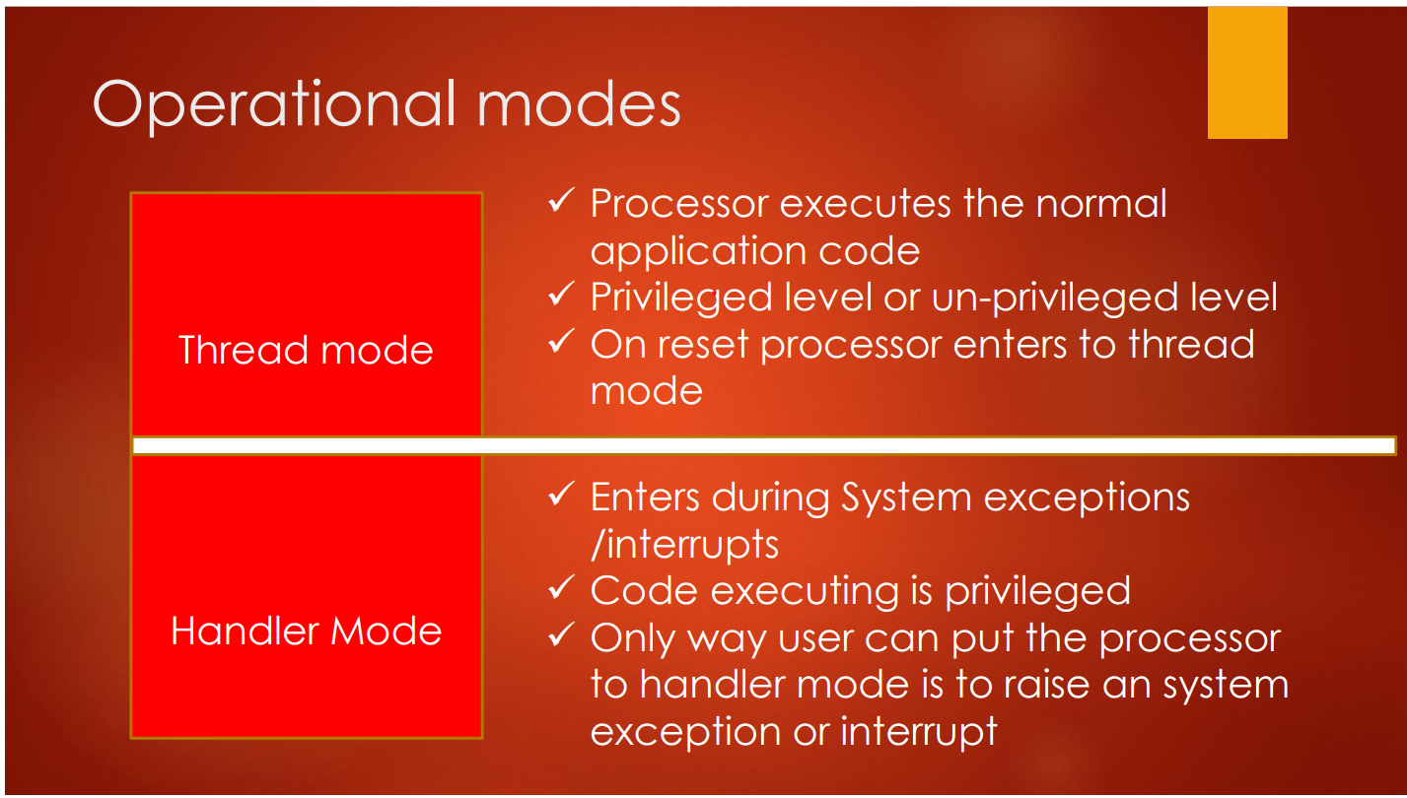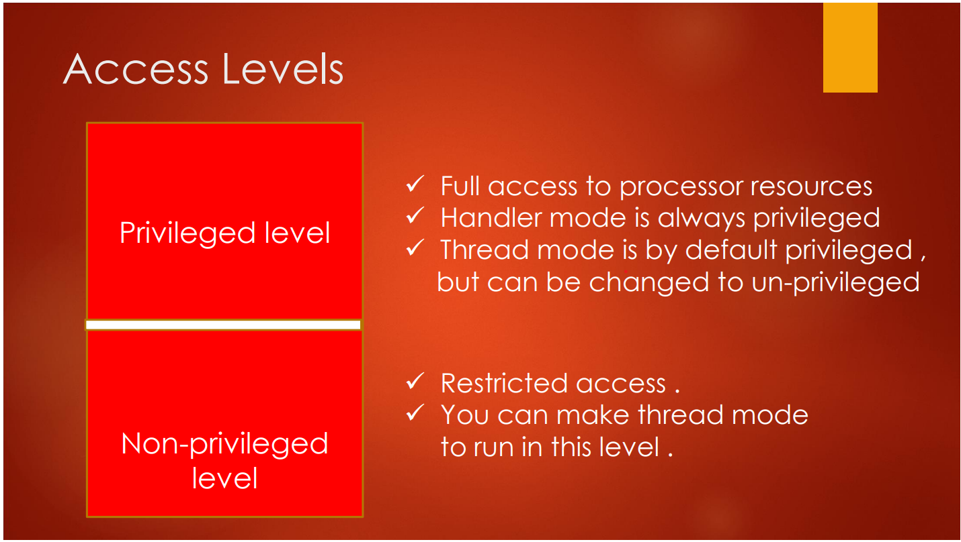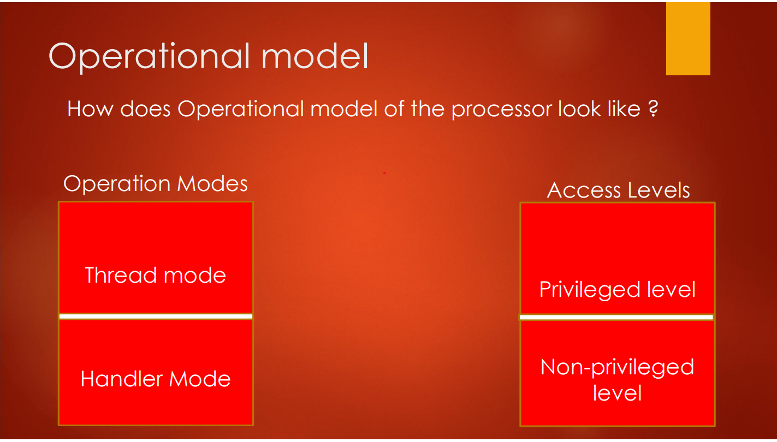Operational Mode of stm32m4

**Switching Between Privileged and Un-Privileged Access Level**

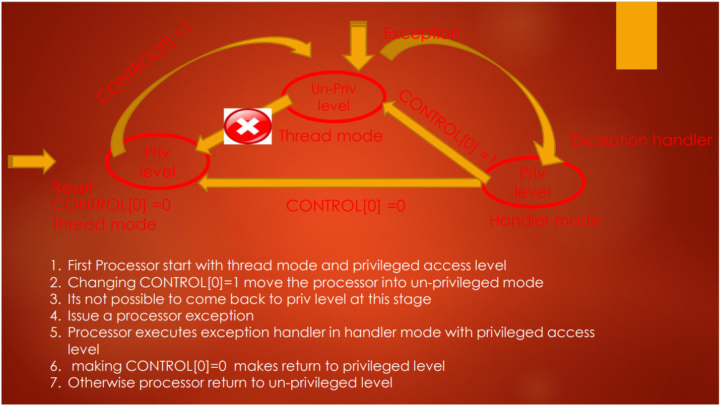

The CONTROL register controls the stack used and the privilege level for software execution when the processor is in Thread mode and, if implemented, indicates whether the FPU state is active.

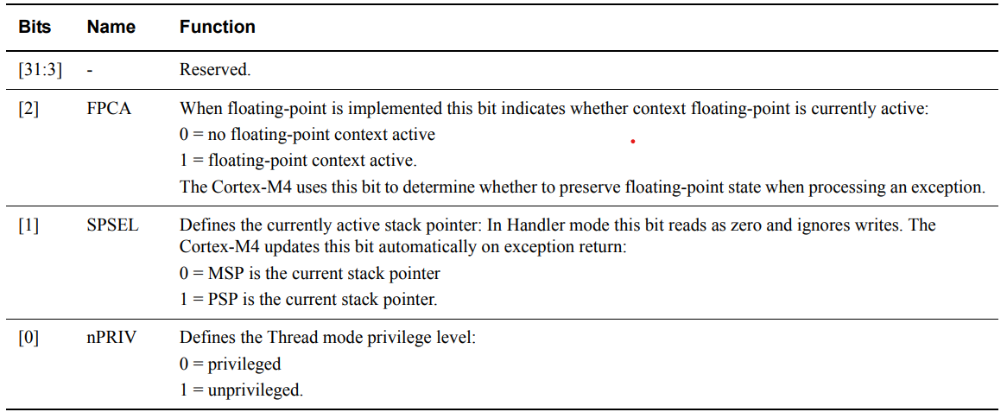

Handler mode always uses the MSP, so the processor ignores explicit writes to the active stack pointer bit of the CONTROL register when in Handler mode.

The exception entry and return mechanisms automatically update the CONTROL register based on the EXC_RETURN value

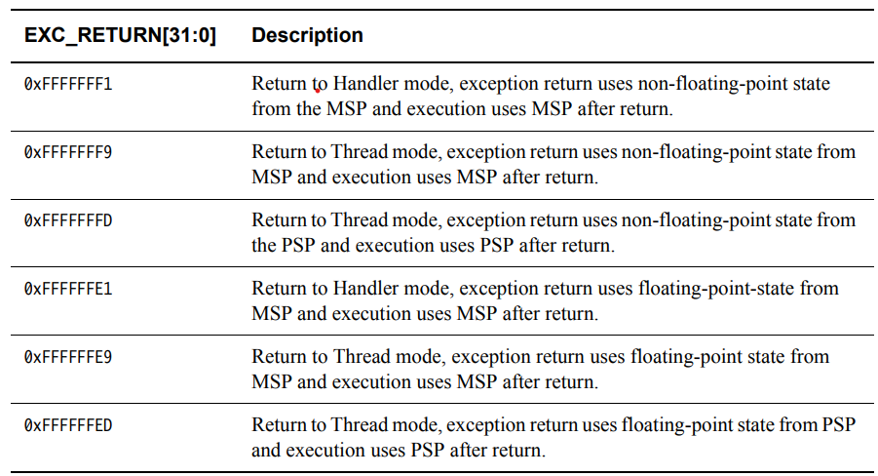

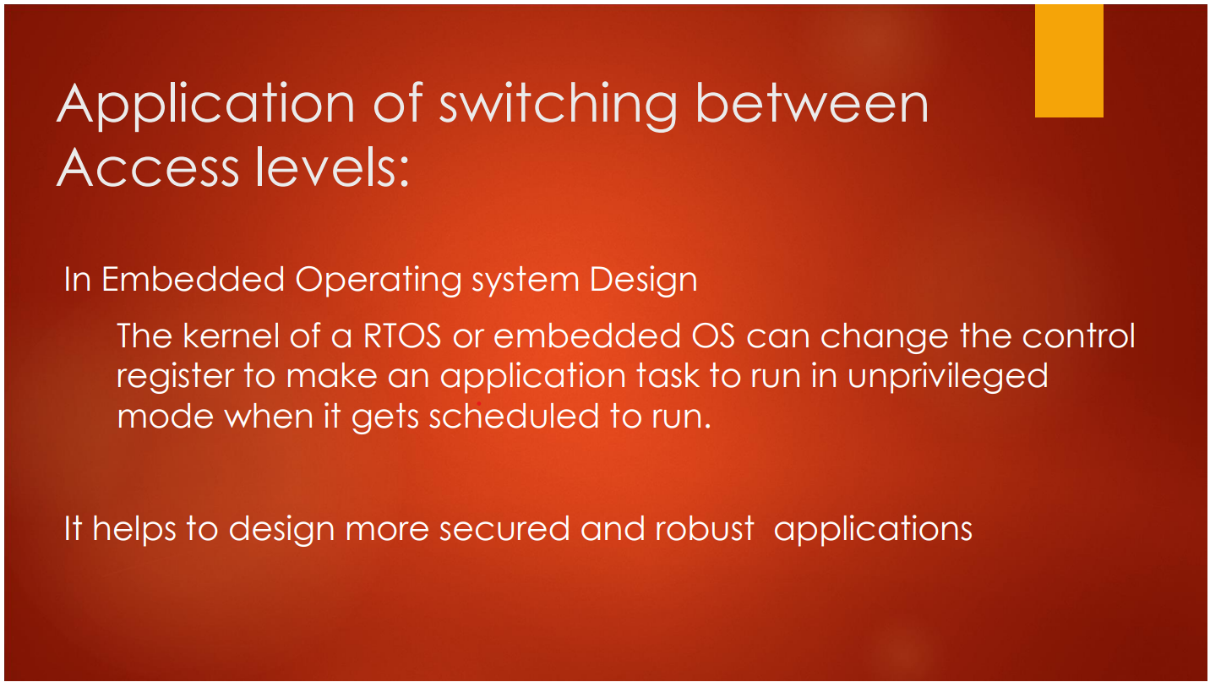

Programmer’s Model (Register Model)

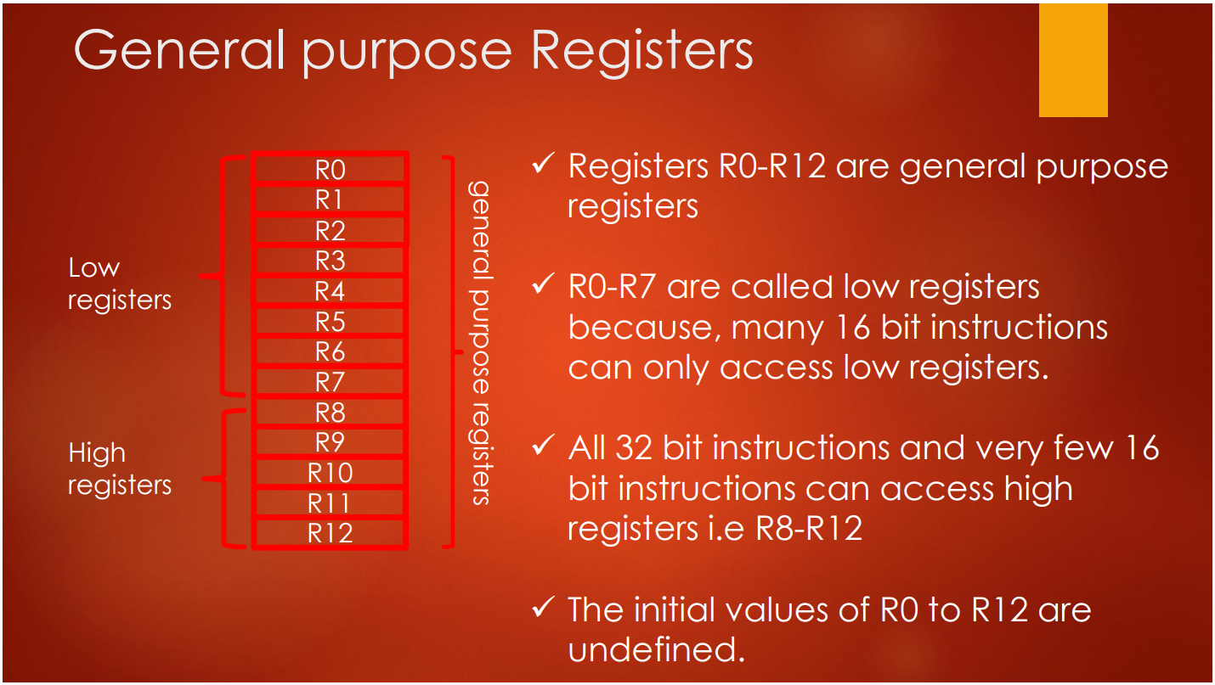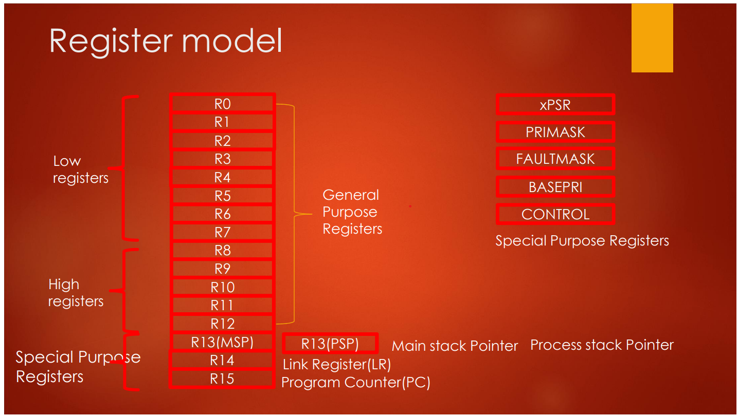

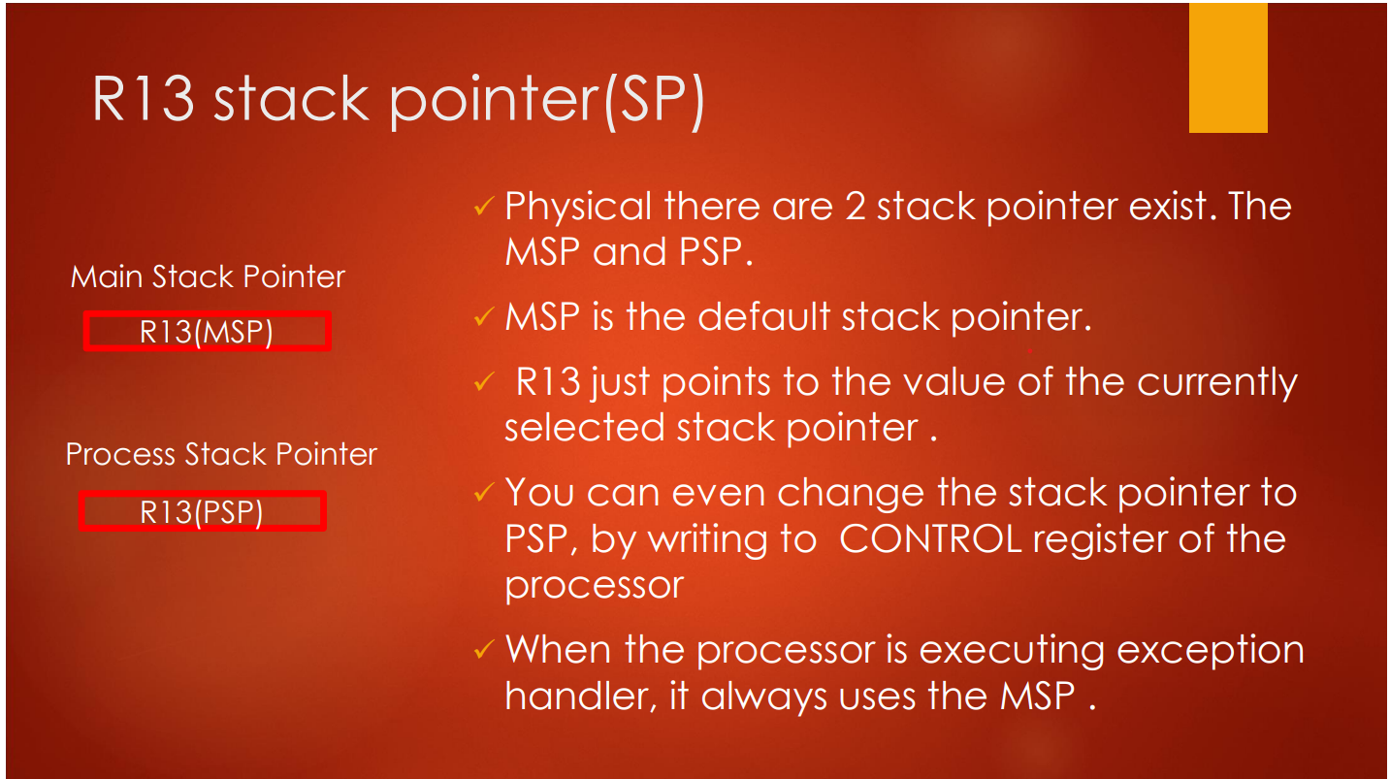

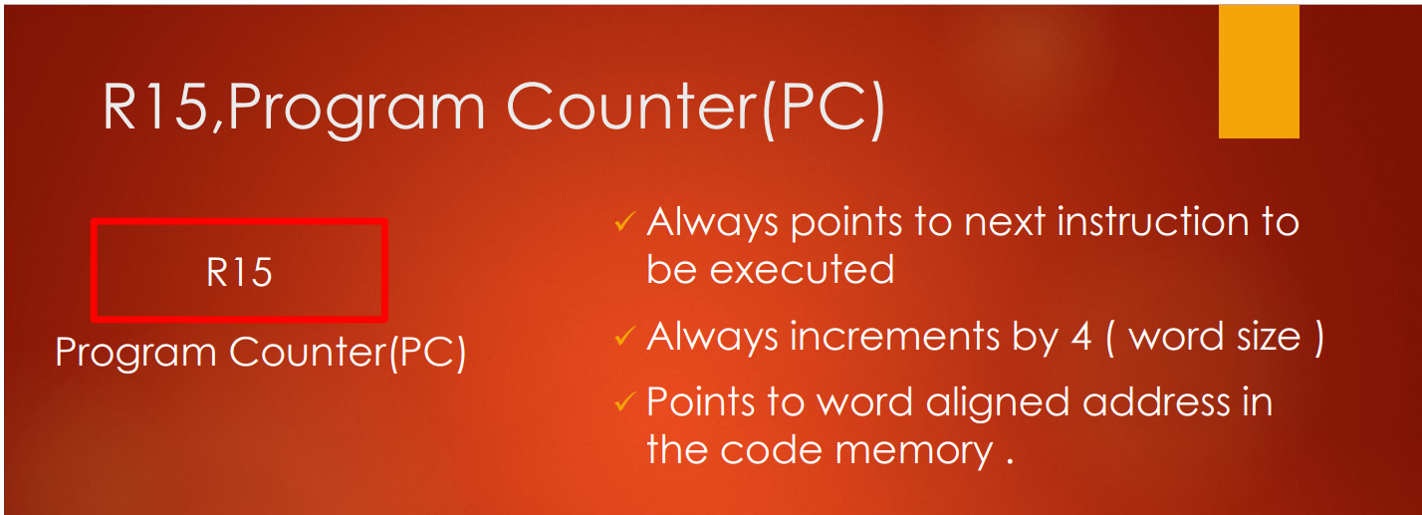

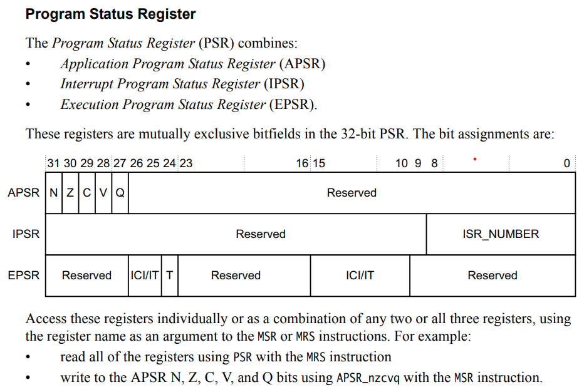Programmer’s Model (Special Purpose Registers)

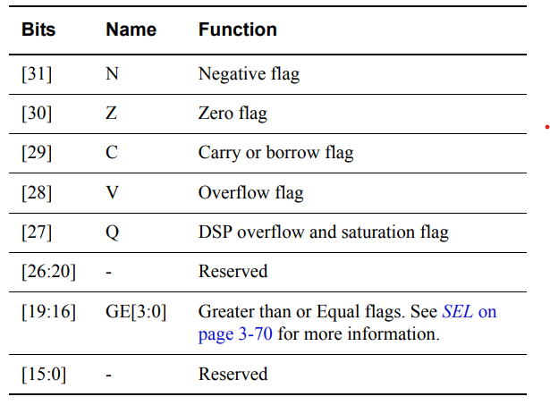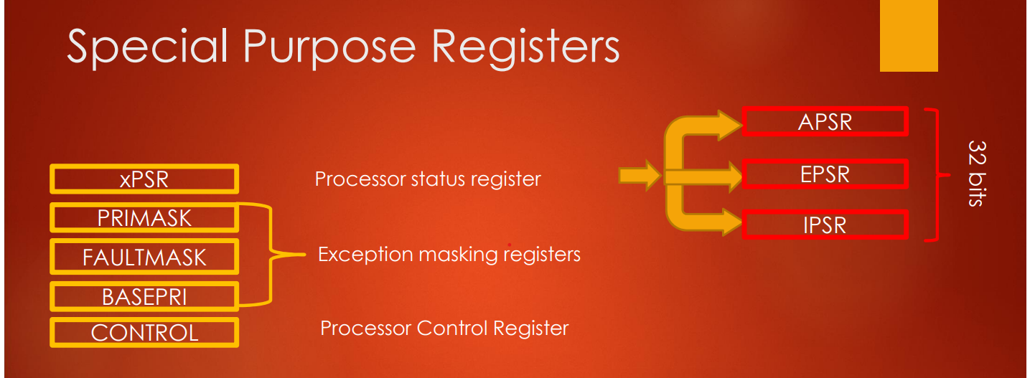

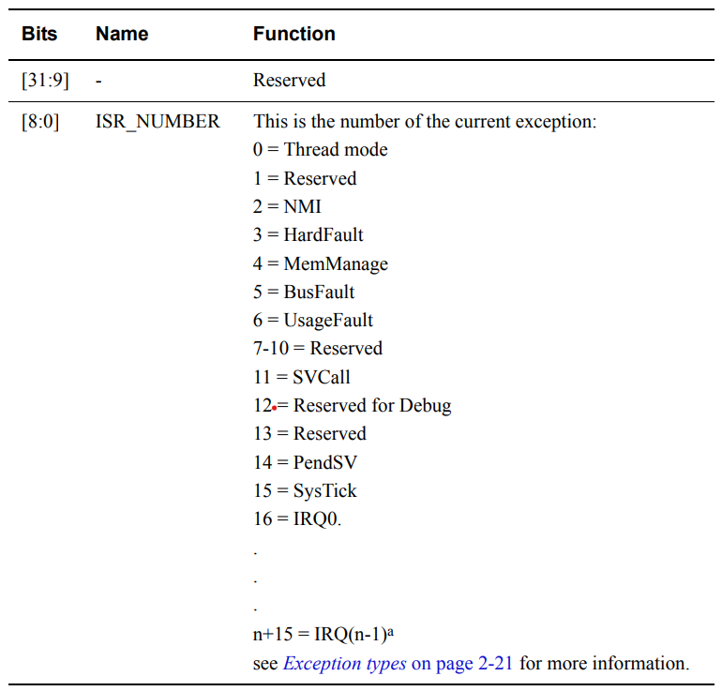

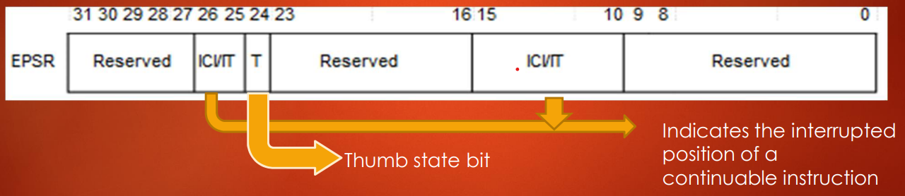

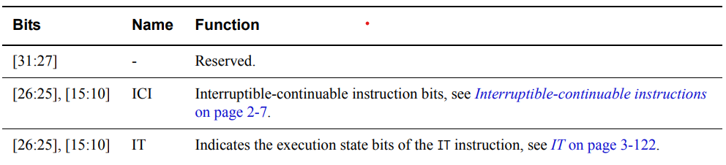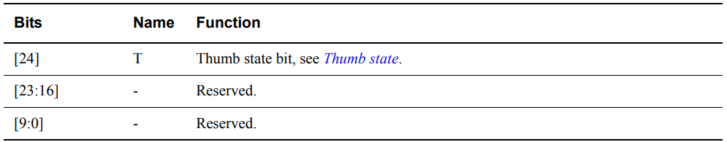

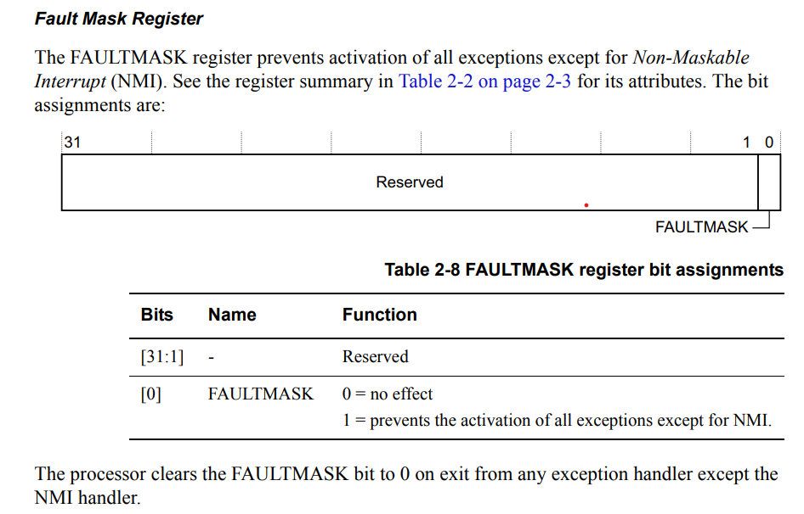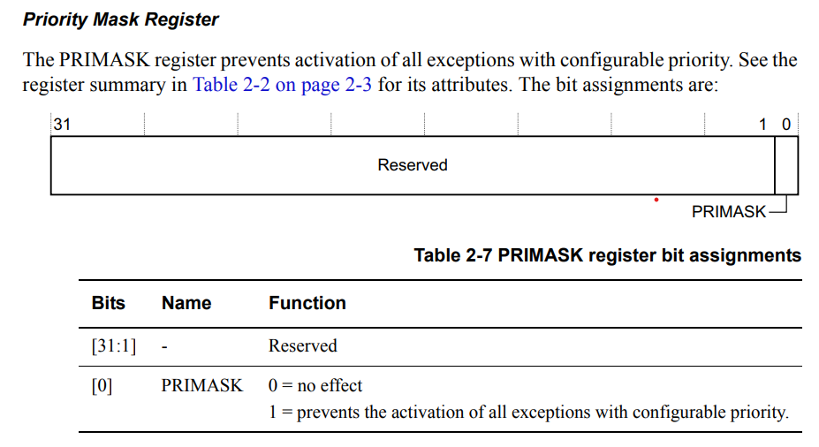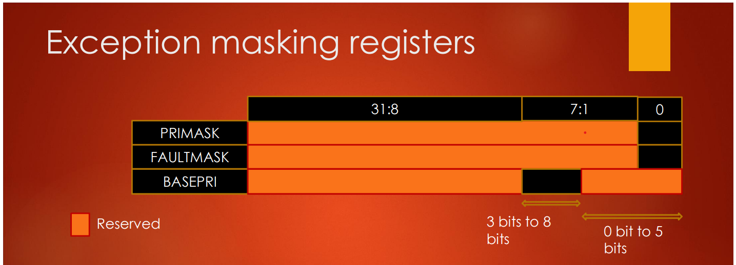

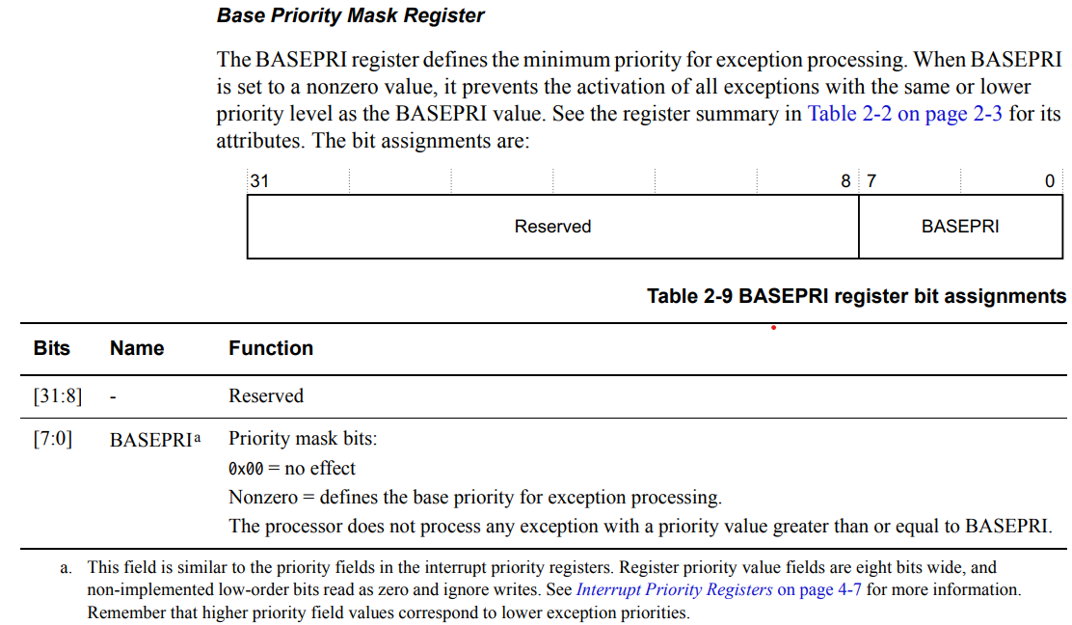

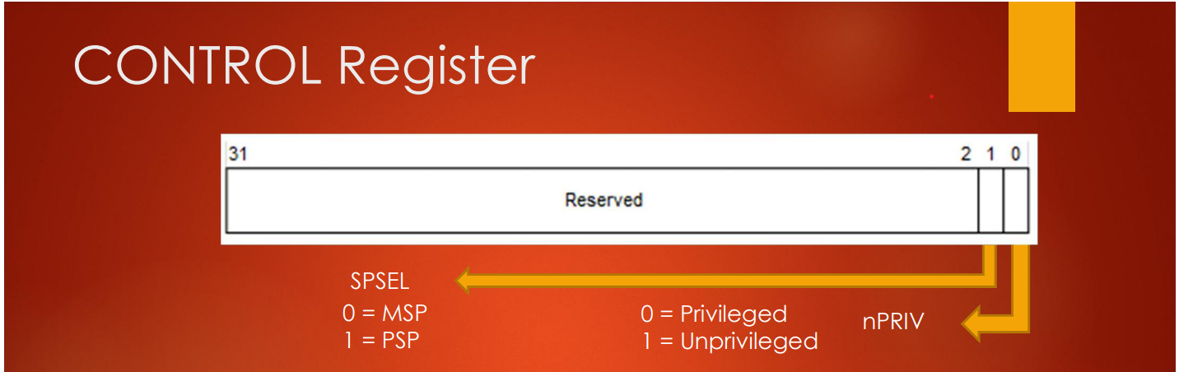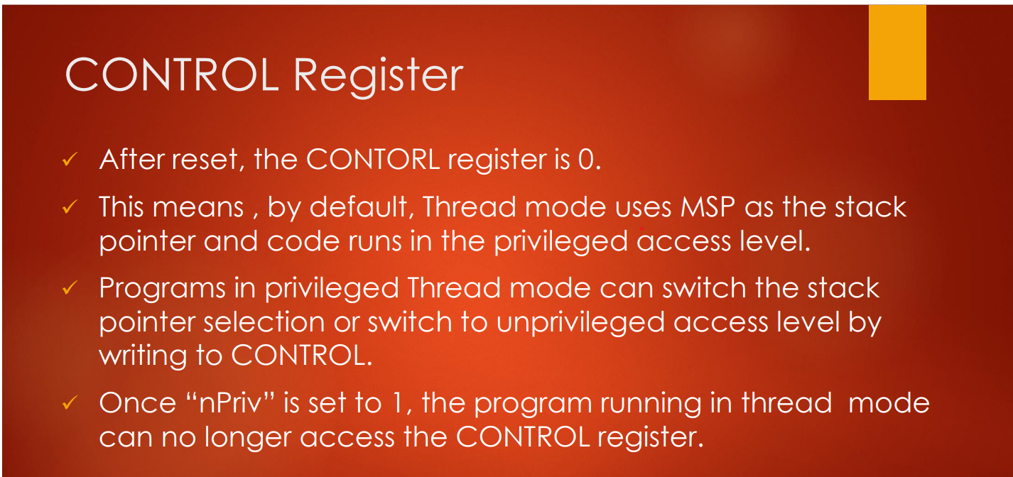

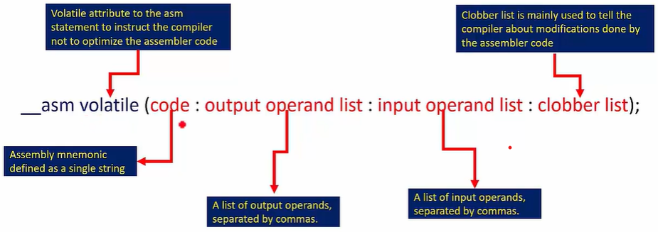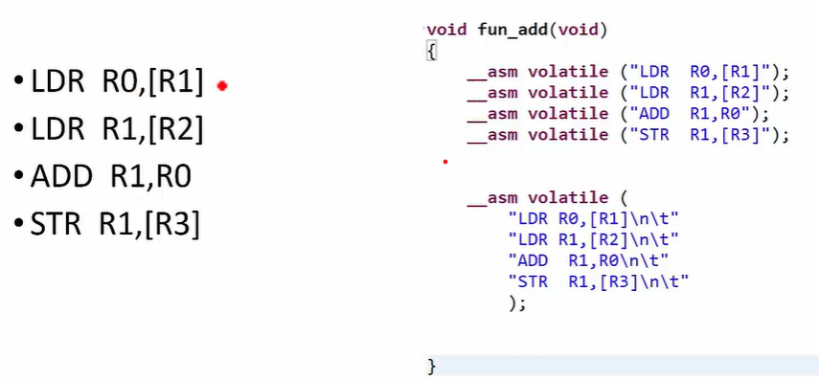Assembly Instruction In C - Program

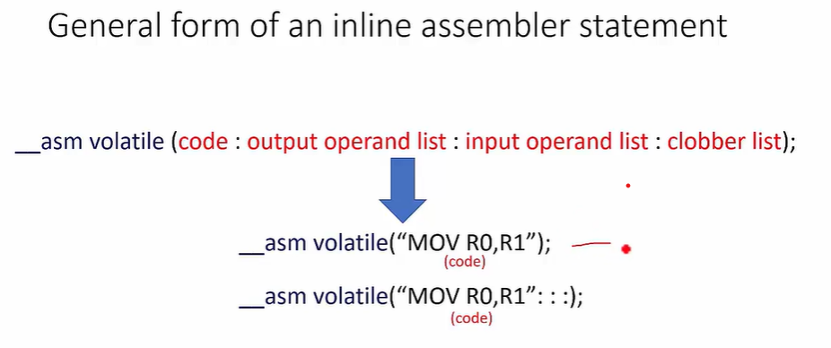

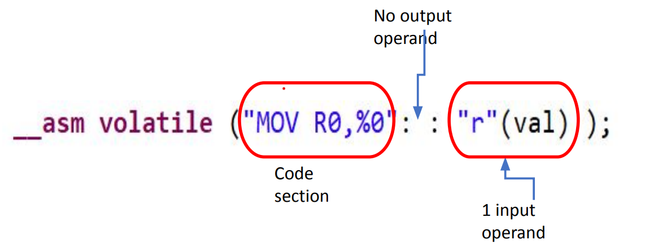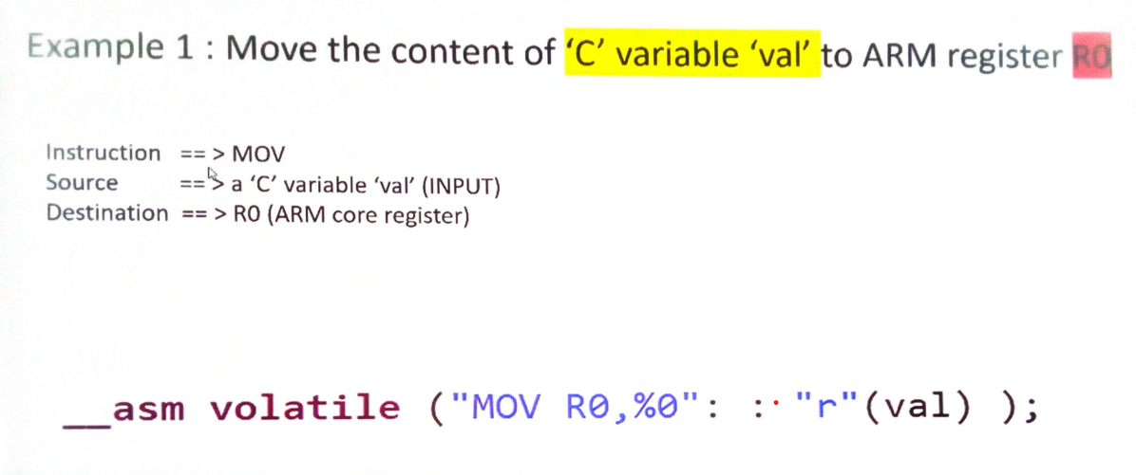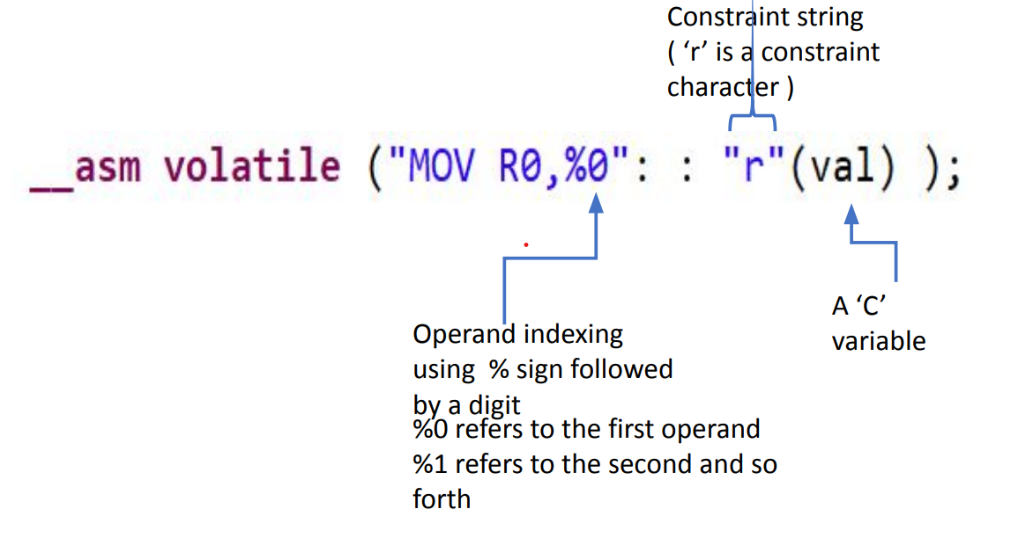

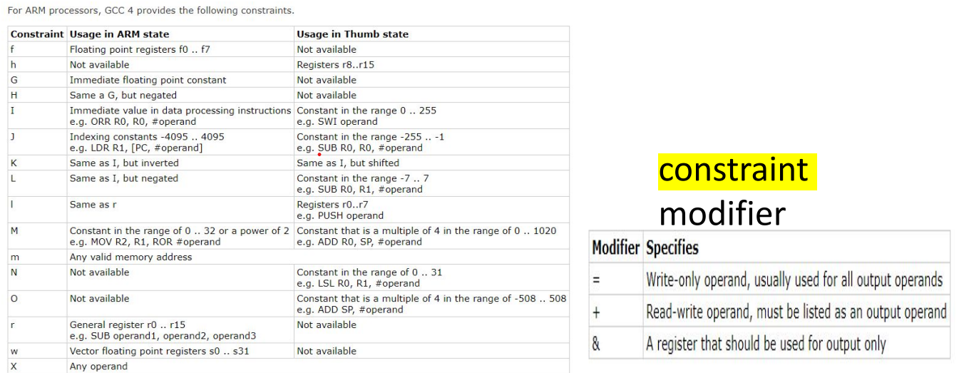

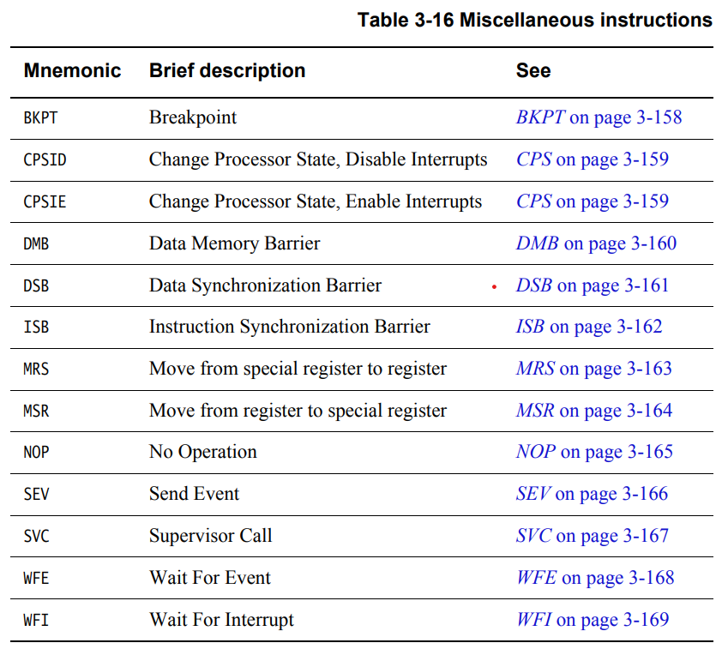

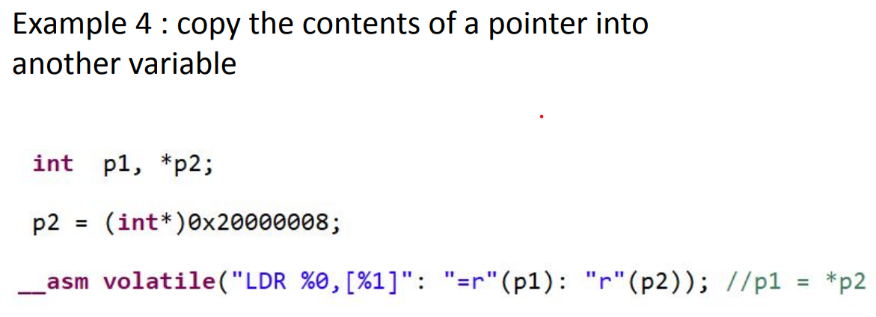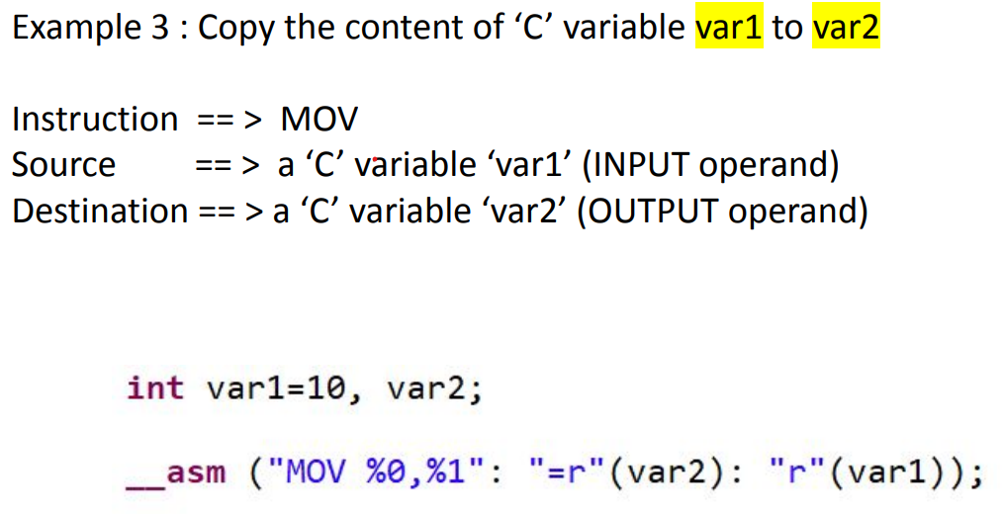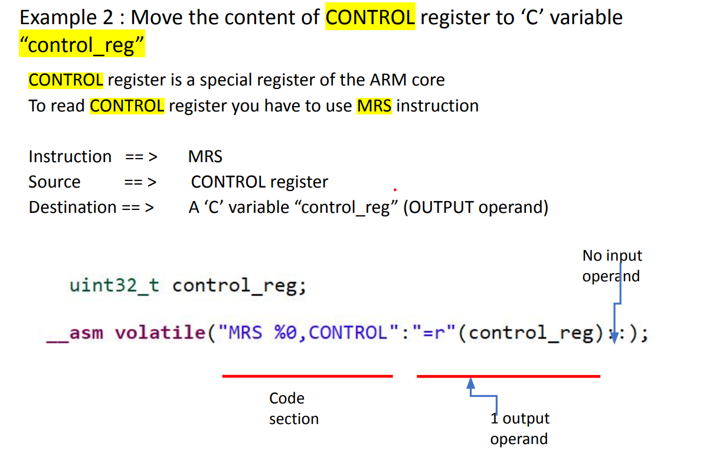

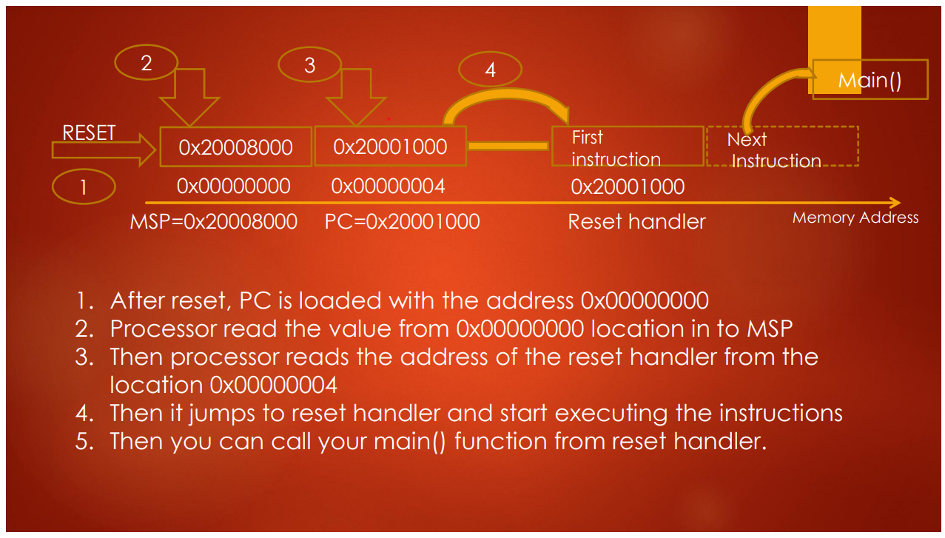Process of Reset Sequence

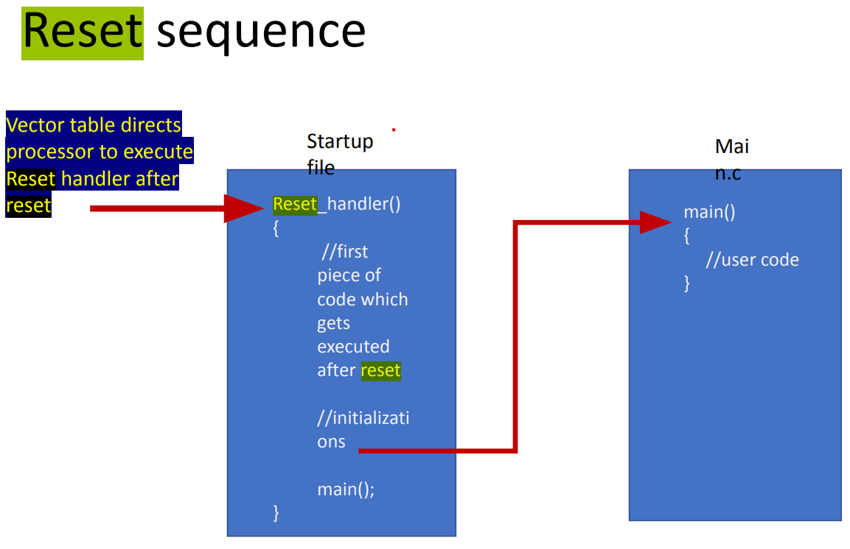

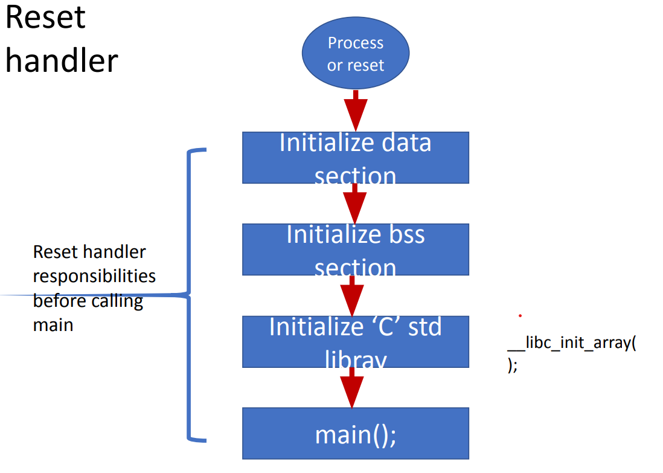

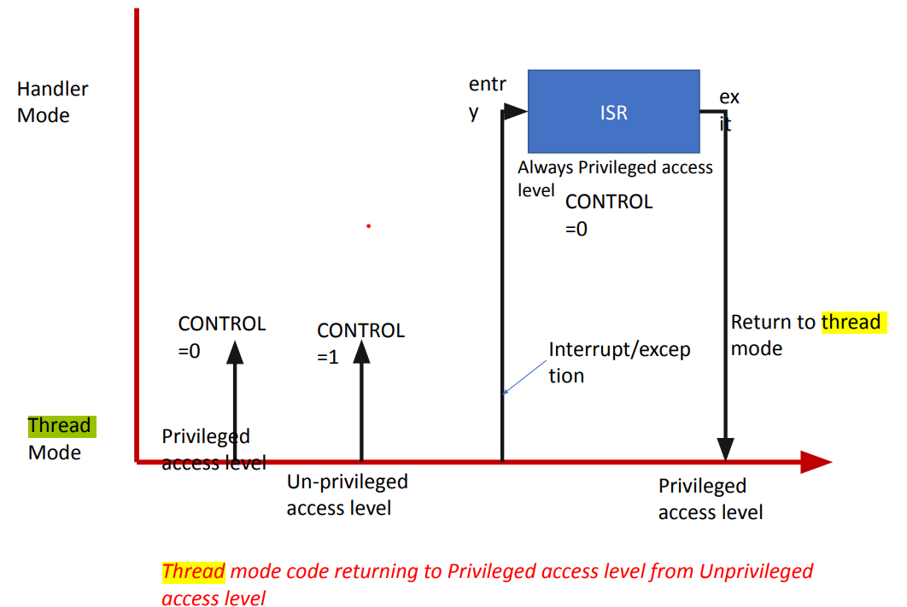Access Level Transition

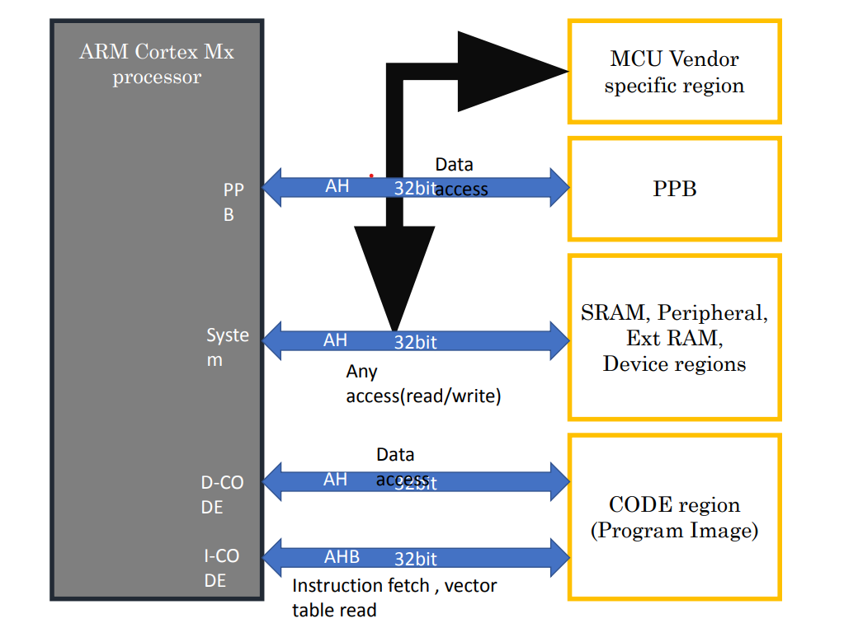Memory Mapping

Bit Banding

**What is bit-banding ?**

• It is the capability to address a single bit of a memory address.

• This feature is optional. i.e., MCU manufacturer supports it or many not support this feature. Refer to the reference manual

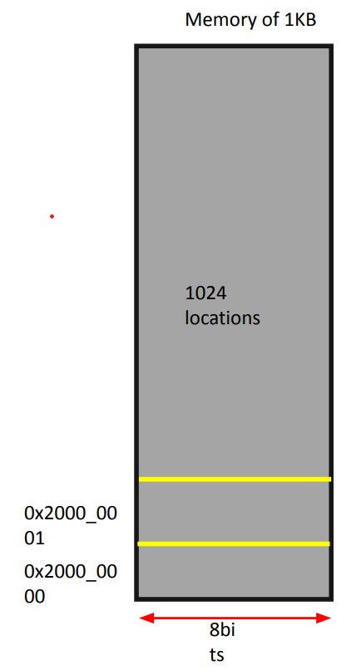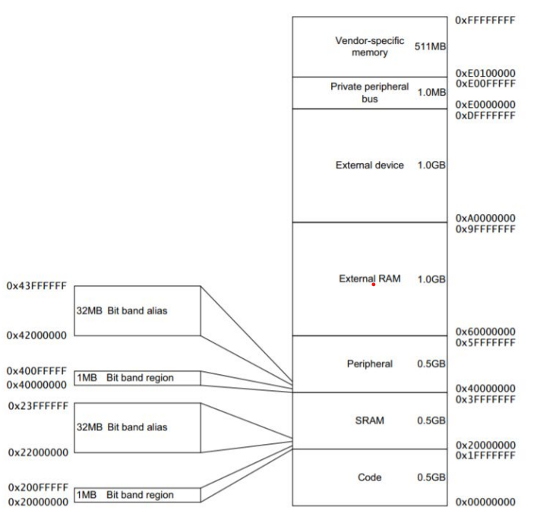

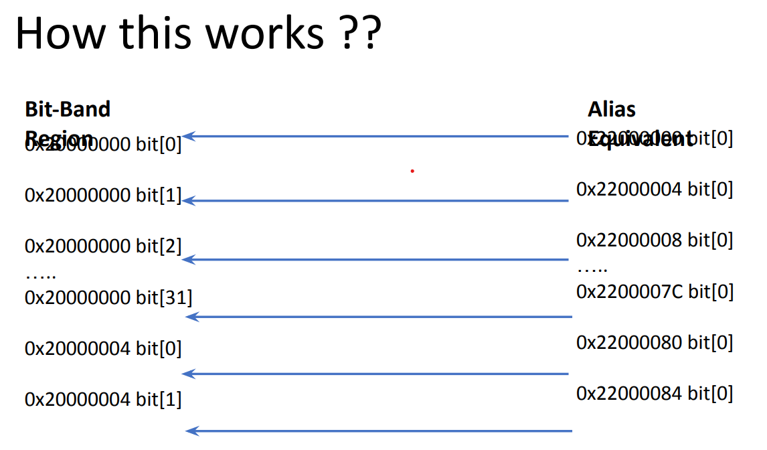

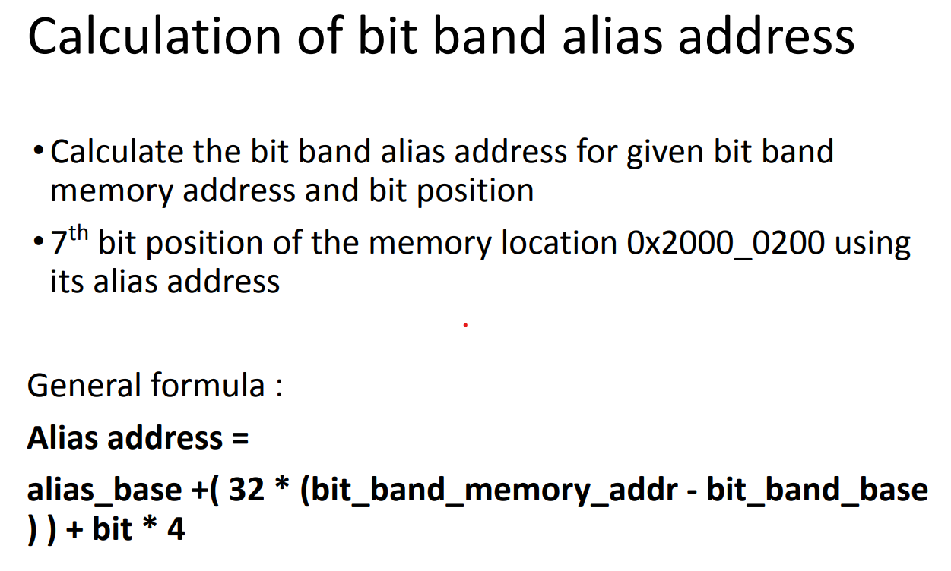

In the Example:-

Alias address = alias_base + (32*(bit_band_memory_addr - bit_band_base)) + bit*4

alias_addr = 0x22000000 + (32 * (0x20000200 - 0x20000000)) + 7 * 4;

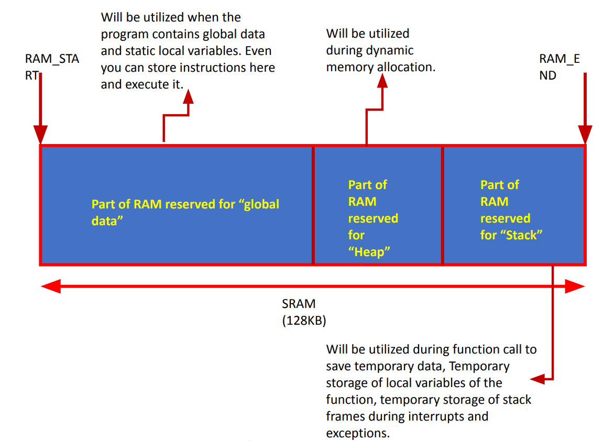Stack Memory

**Different Stack operation models**

• Full Ascending stack (FA)

• Full Descending stack(FD) (ARM Cortex Mx processors use this)

• Empty Ascending stack(EA)

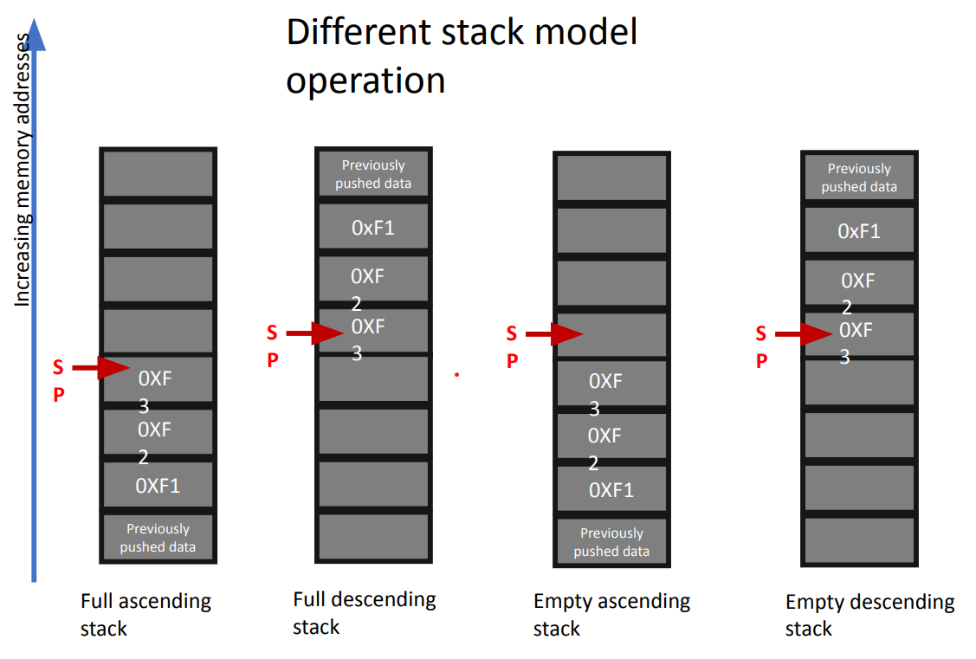• Empty Descending stack(ED)

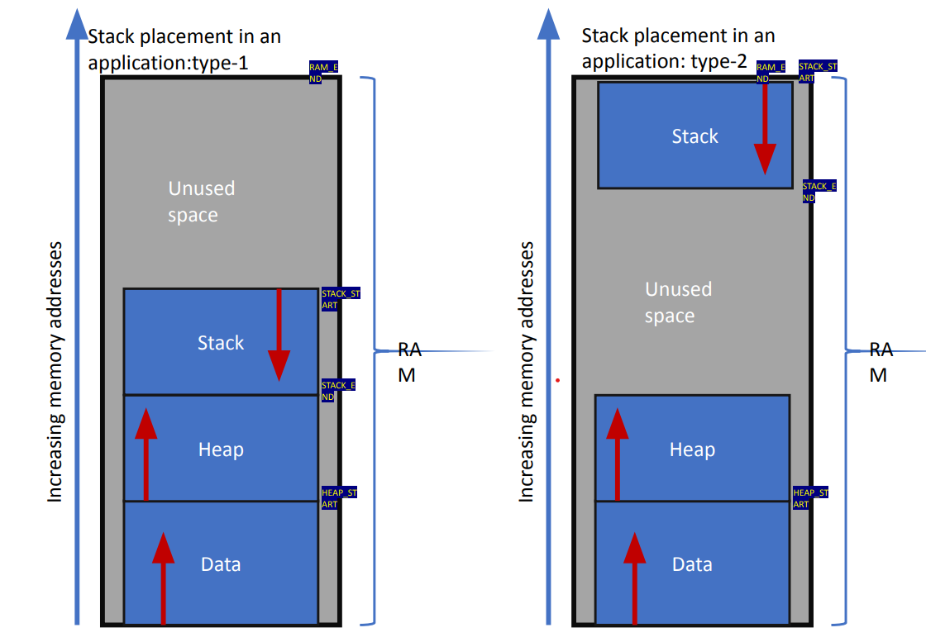

Function Call and AAPCS standard

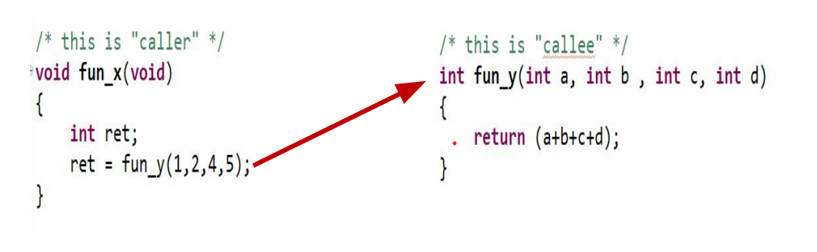

**Stack activities during function call**

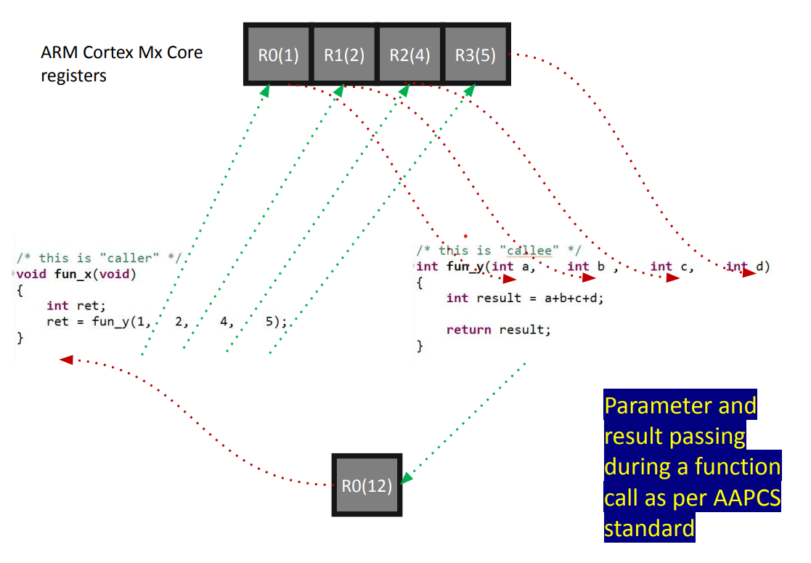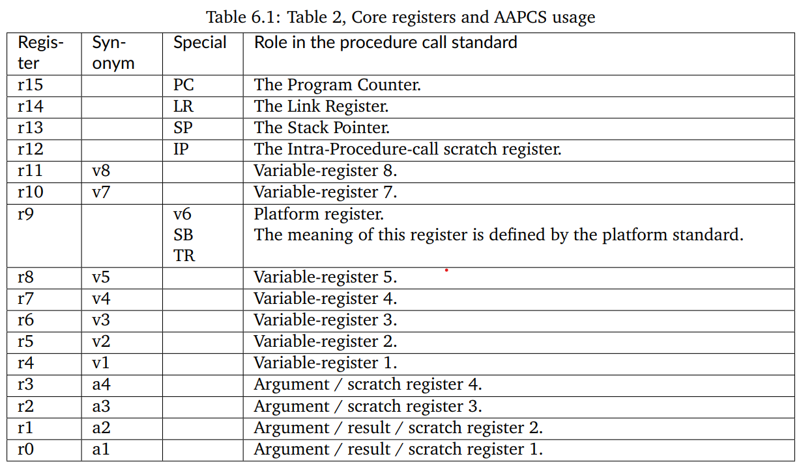

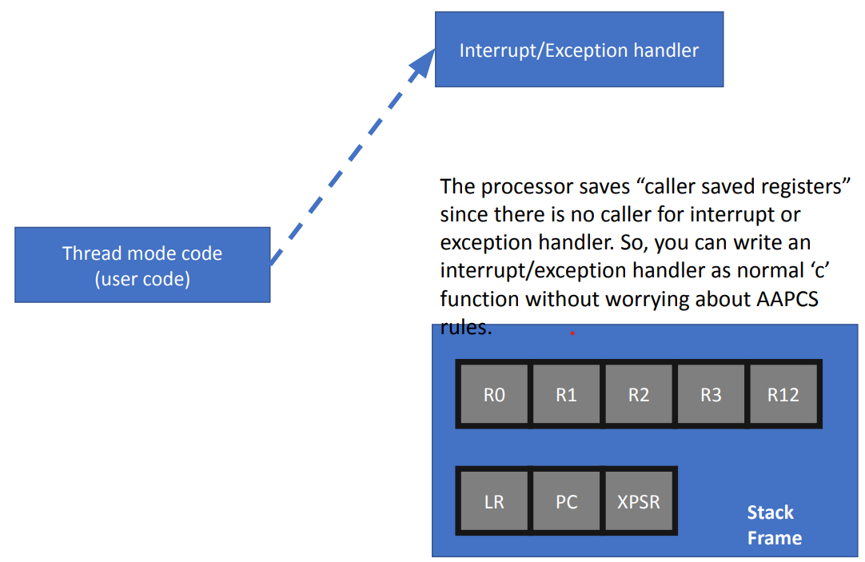**Stack activities during interrupt and exception**

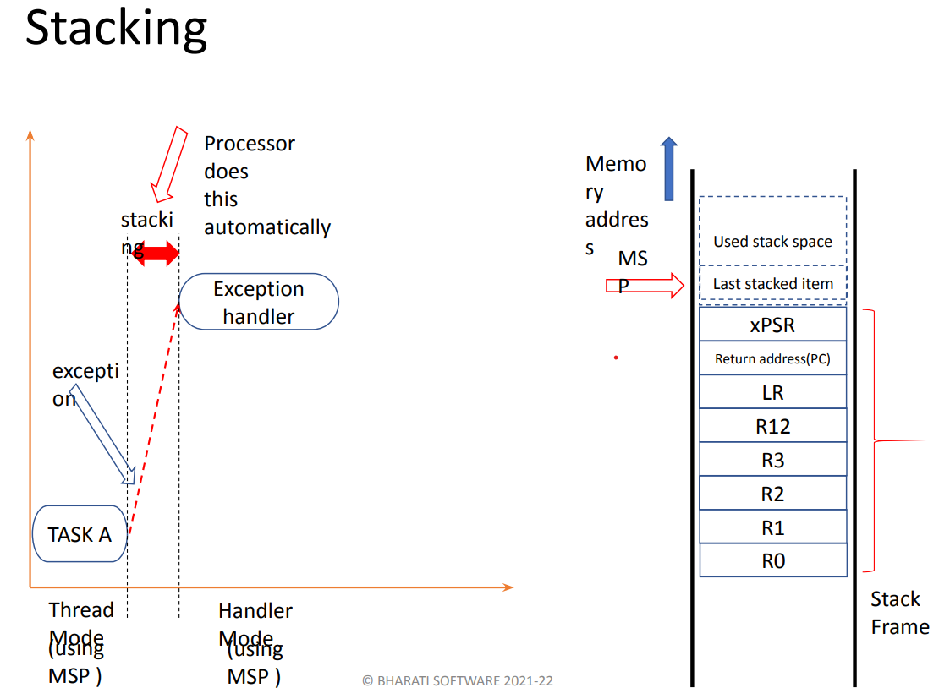

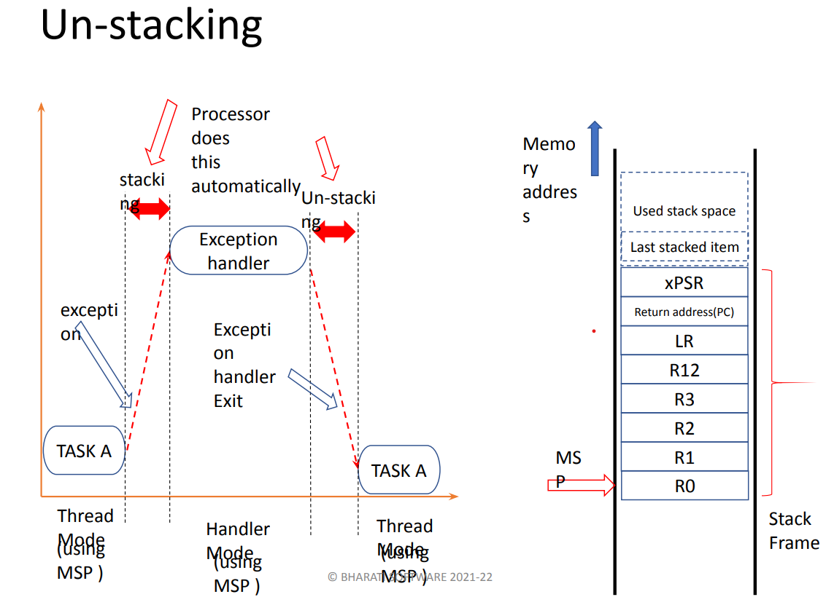

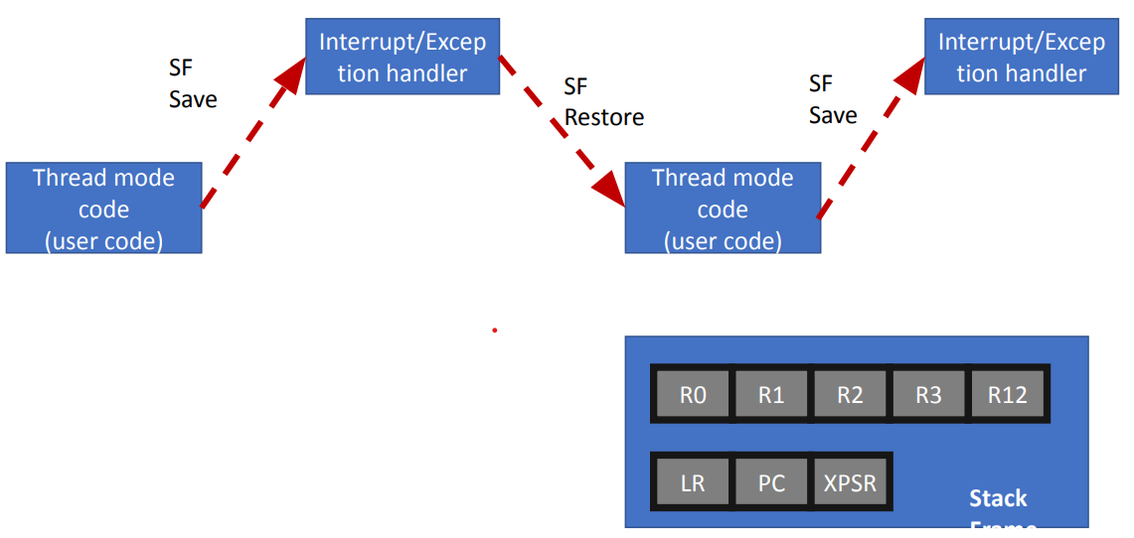

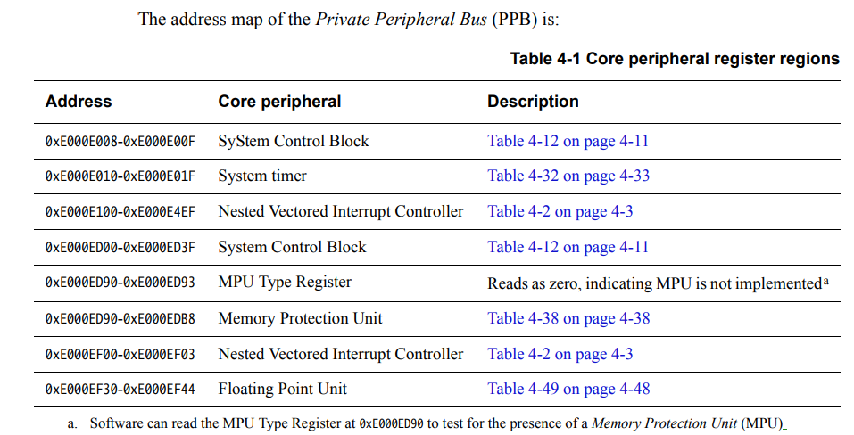The address map of the Private Peripheral Bus (PPB)

**System Control Block(SCB)**

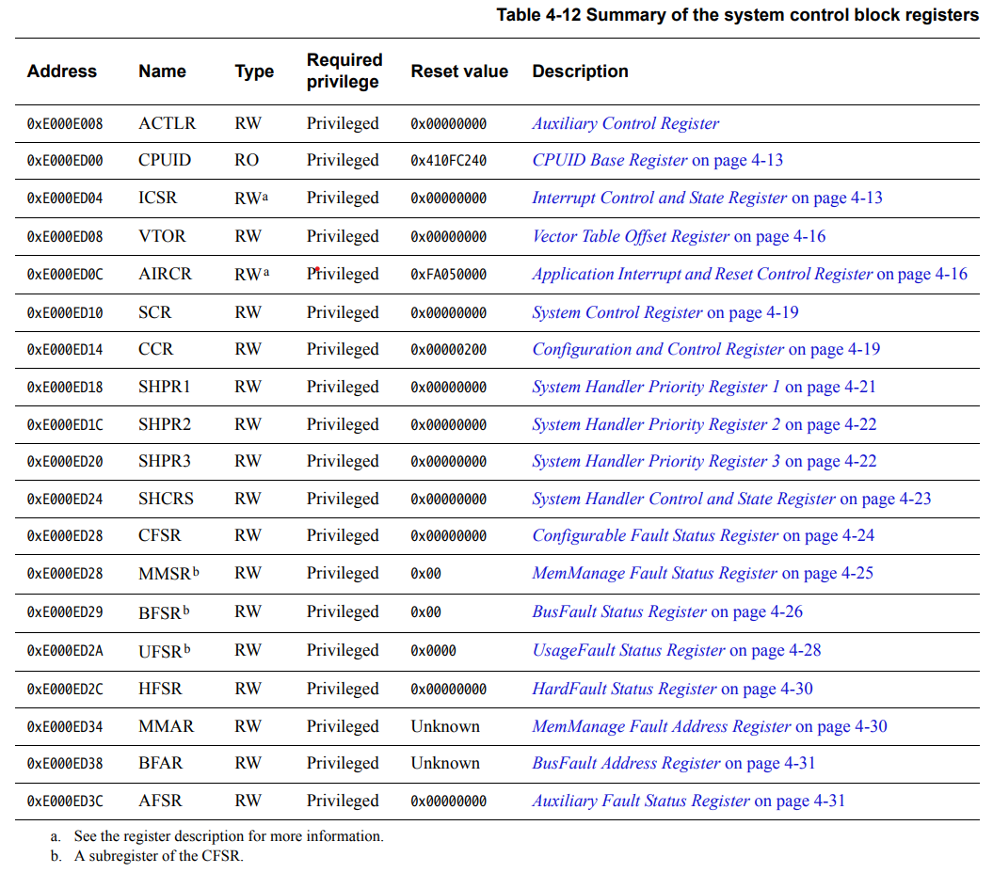

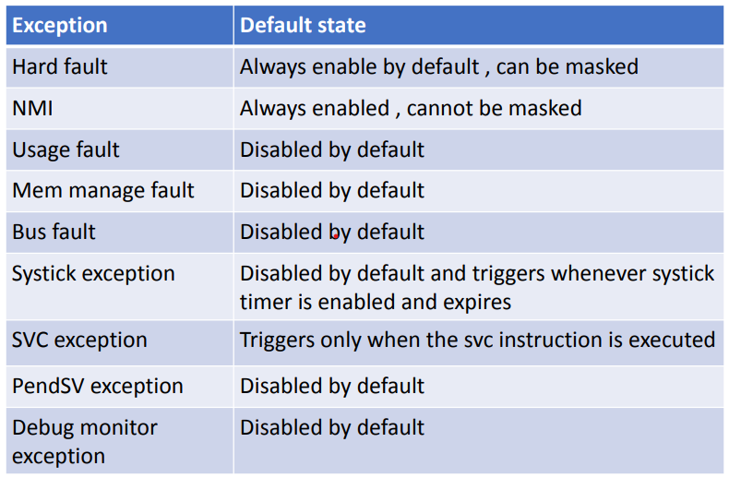**Default system exception status**

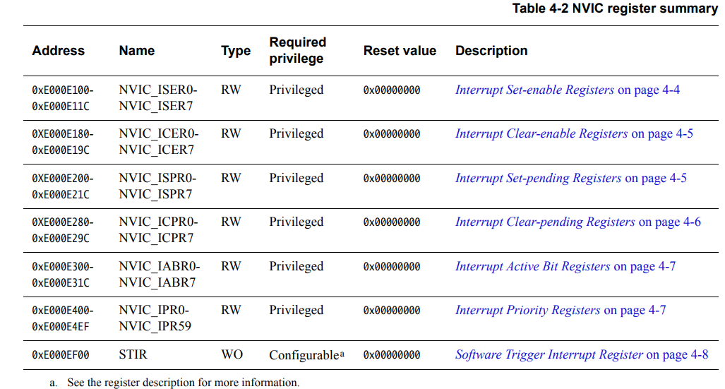**NVIC Register Summery**

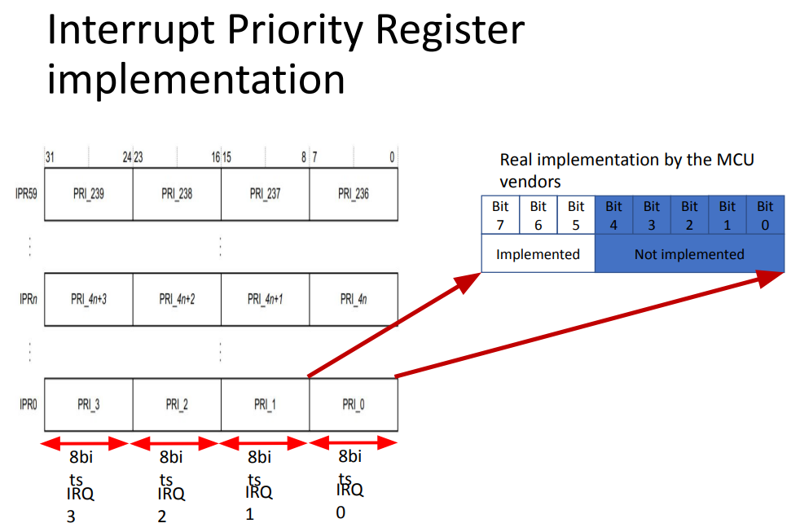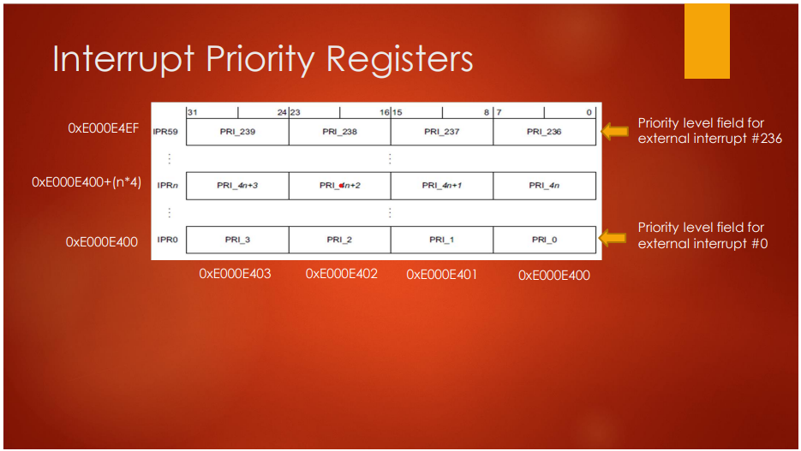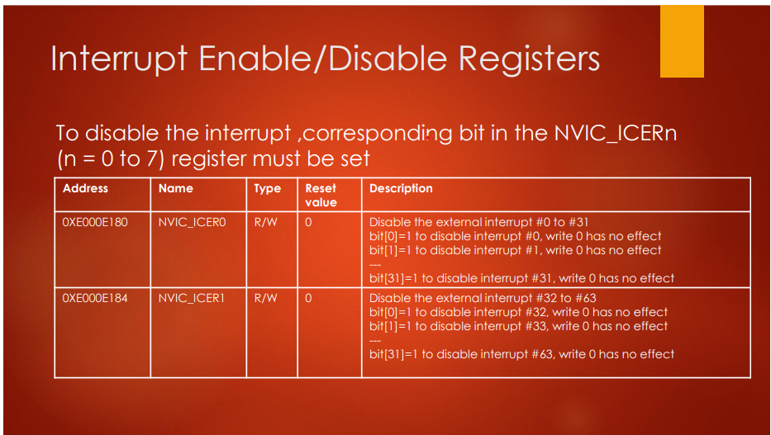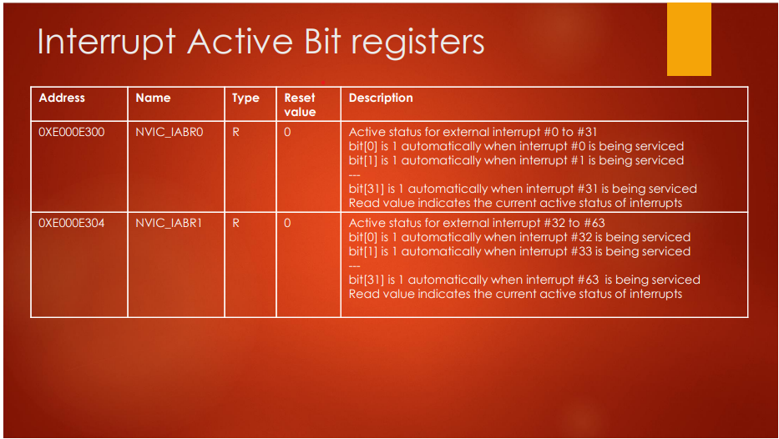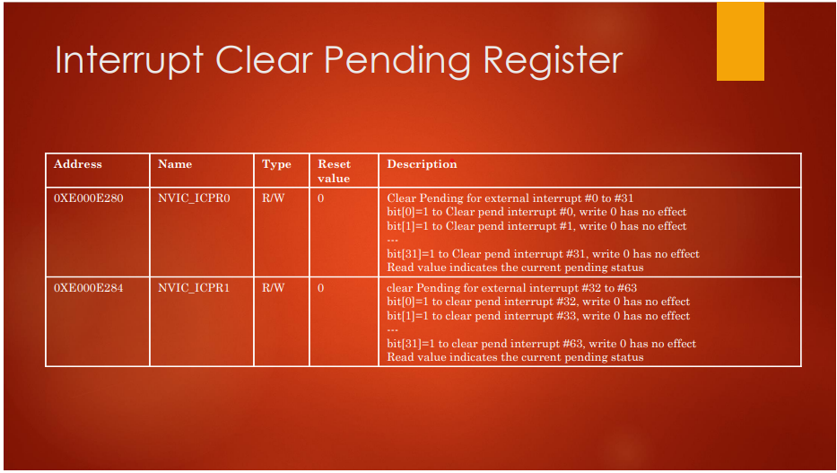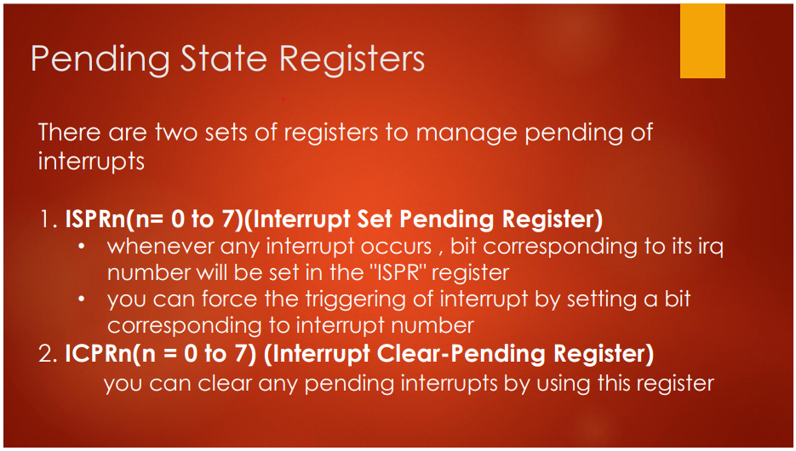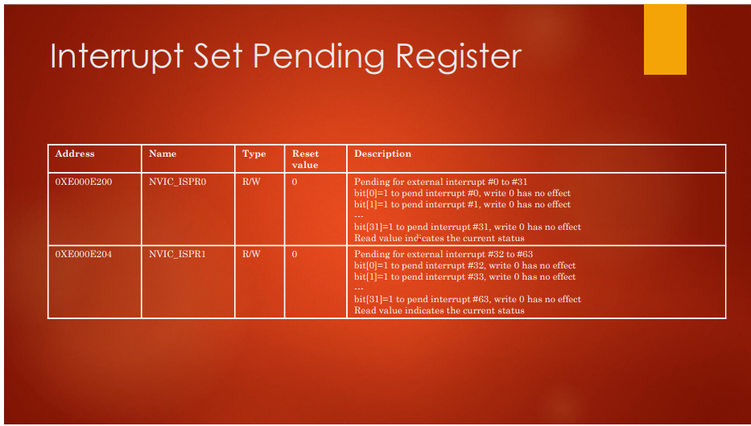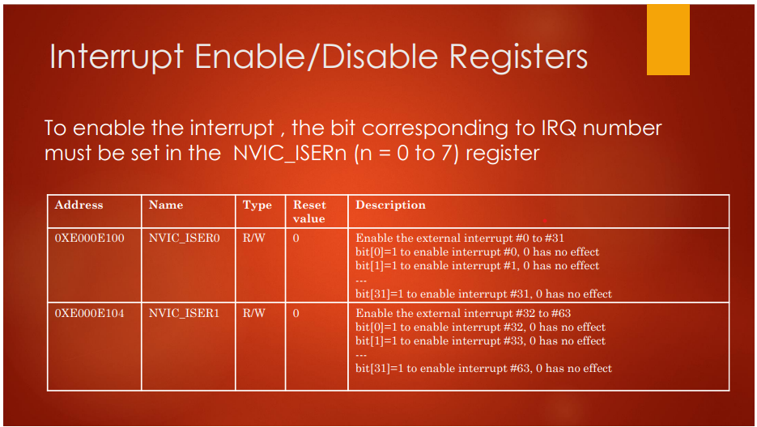

**Steps to program an MCU peripheral interrupt**

• Identify the IRQ number of the peripheral by referring to the MCU vector table. IRQ numbers are vendor-specific

• Program the Processor register to enable that IRQ (only when you enable the IRQ, the processor will accept the interrupt over that line ).Set the priority (optional)

• Configure the peripheral (USART3) using its peripheral configuration register. For example, in the case of USART3, whenever a packet is received, it will automatically issue an interrupt on the IRQ line 39.

• When the interrupt is issued on the IRQ line, it will first get pended in the pending register of the processor

• NVIC will allow the IRQ handler associated with the IRQ number to run only if the priority of the new interrupt is higher than the currently executing interrupt handler. Otherwise newly arrived interrupt will stay in pending state.

• Please note that if peripheral issues an interrupt when the IRQ number is disabled (not activated from the processor side ), then still interrupt will get pended in the pending register of the NVIC. As soon as IRQ is enabled, it will trigger the execution of the ISR if the priority is higher than the currently active ISR.

**Exercise-Enabling and Pending of USART3 Interrupt**

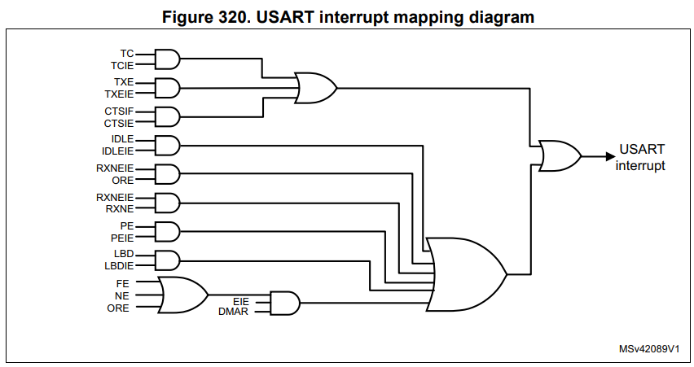

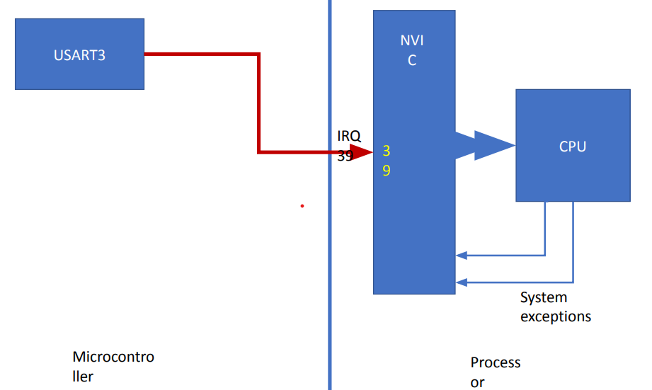

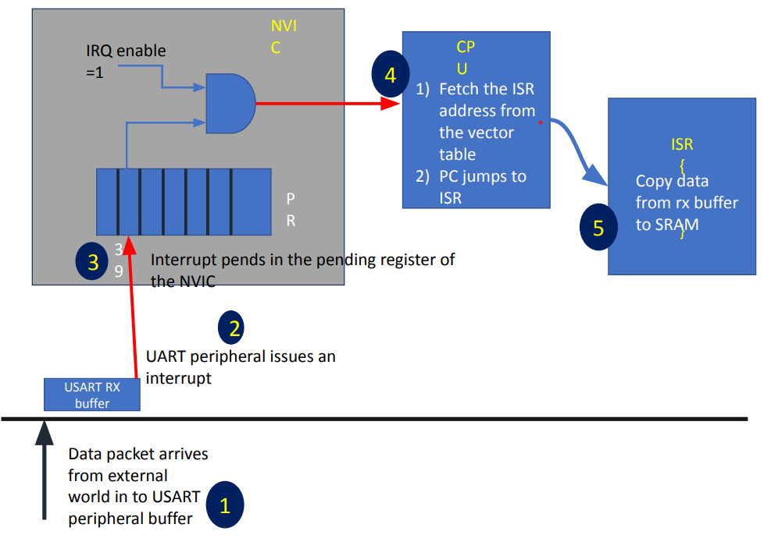

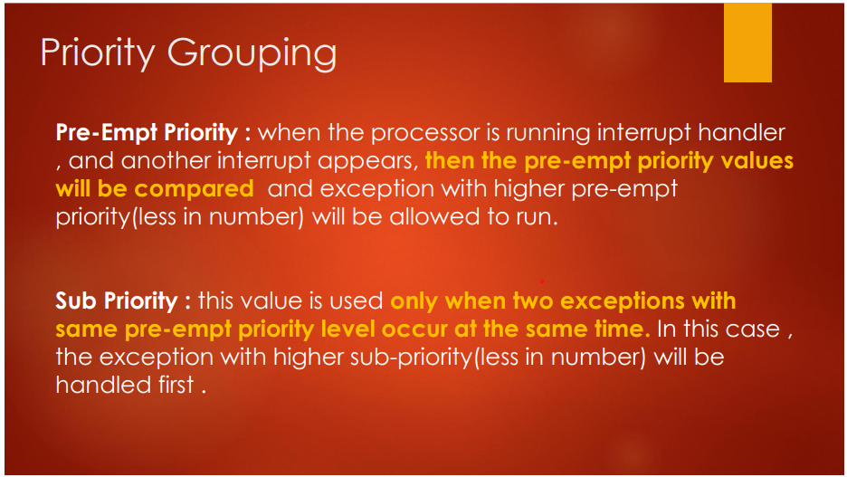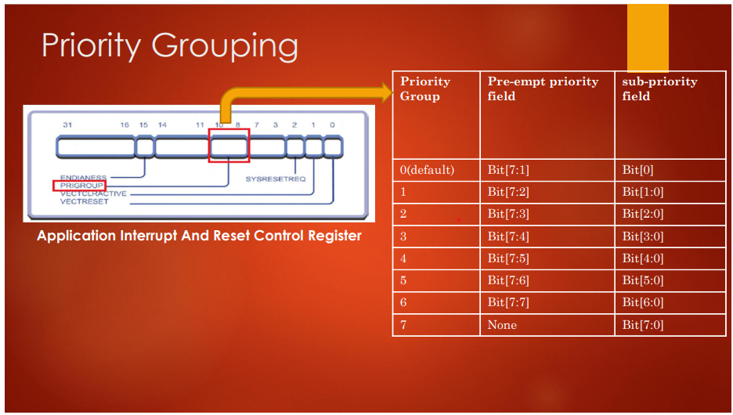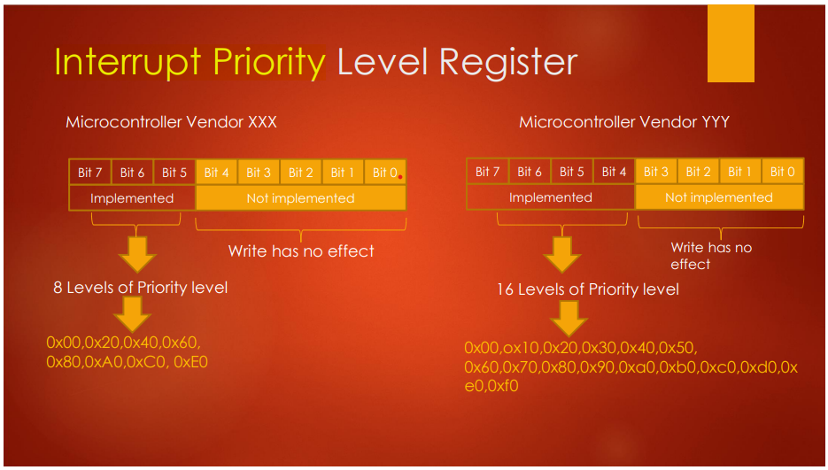Interrupt Priority

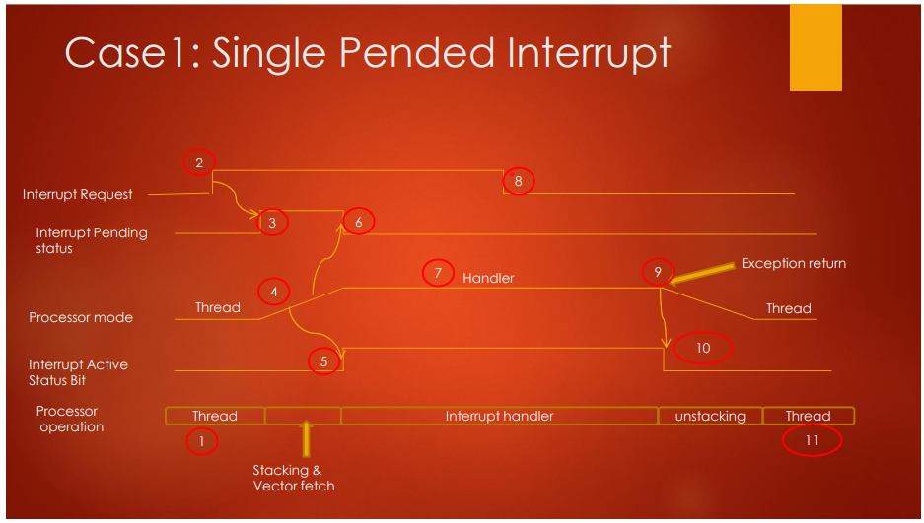Pending Interrupt Behaviour

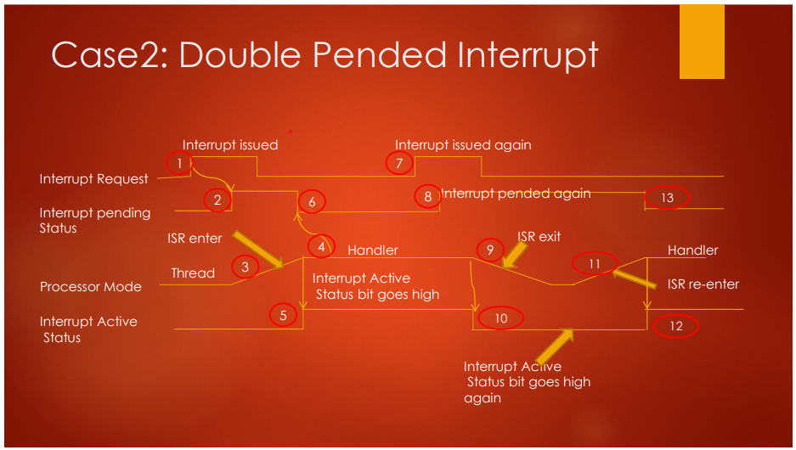

**When it is generated ??**

During an exception handler entry , the value of the return address(PC) Is not stored in the LR as it is done during calling of a normal C function. Instead The exception mechanism stores the special value called EXC_RETURN in LR.

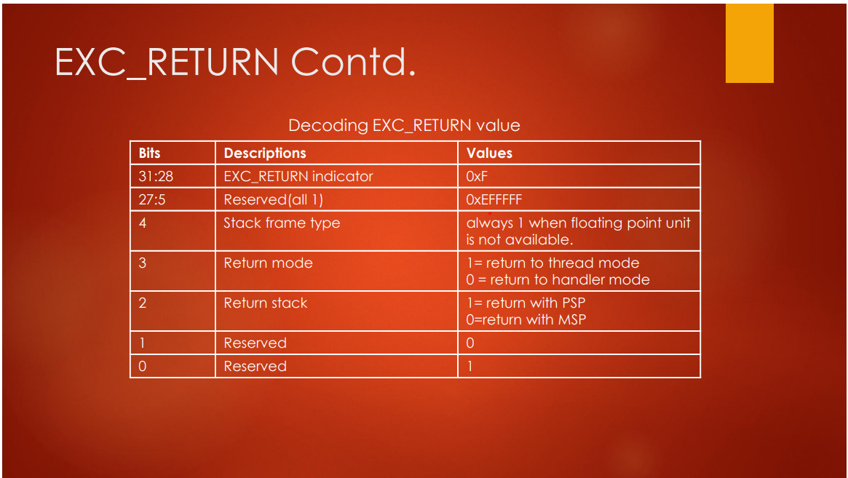

(LR Register)

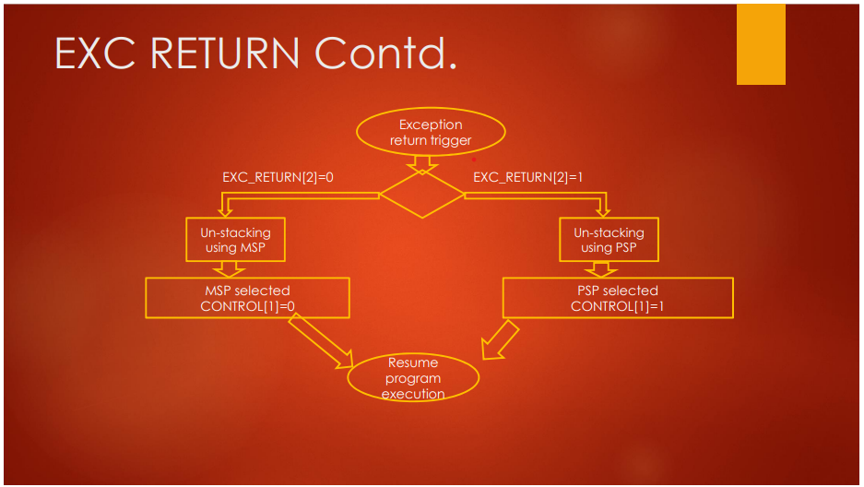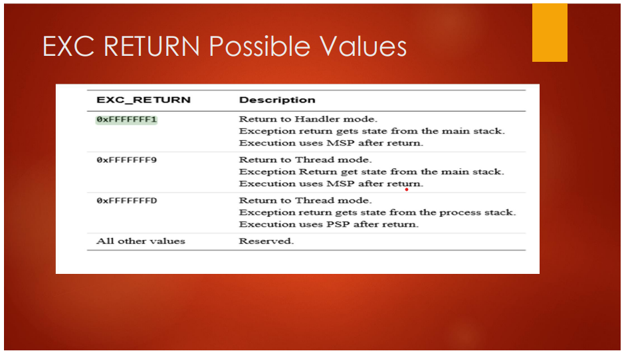

Processor Fault Exceptions

*Different types of fault exceptions in Cortex Mx processor*

**•Hard fault exception\*** {Enabled by default , non-configurable priority}

**•Usage fault exception**

**•Mem manage fault exception** { Disabled by default , configurable priority}

**•Bus fault exception**

**Causes of fault**

✔ Divide by zero (if enabled )

✔ Undefined instruction

✔ Attempt to execute code from memory region which is marked as execute never (XN) to

prevent code injection

✔ MPU guarded memory region access violation by the code

✔ Unaligned data access (if enabled )

✔ Returning to thread mode keeping active interrupt alive

✔ Bus error (example no response from memory device (e.g., SDRAM) )

✔ Executing SVC instruction inside SVC handler or calling a function in SVC handler which

eventually execute hidden SVC instruction

✔ Debug monitor settings and related exceptions

**Hard-fault exception:**

A HardFault is an exception that occurs because of an error during exception processing, or because an exception cannot be managed by any other exception mechanism. It has 3rd highest fixed priority (-1) after reset and NMI meaning it has higher priority than any exception with configurable priority

**Causes**

1) Escalation of configurable fault exceptions

2) Bus error returned during a vector fetch

3) Execution of break point instruction when both halt mode and debug monitor is disabled

4) Executing SVC instruction inside SVC handler

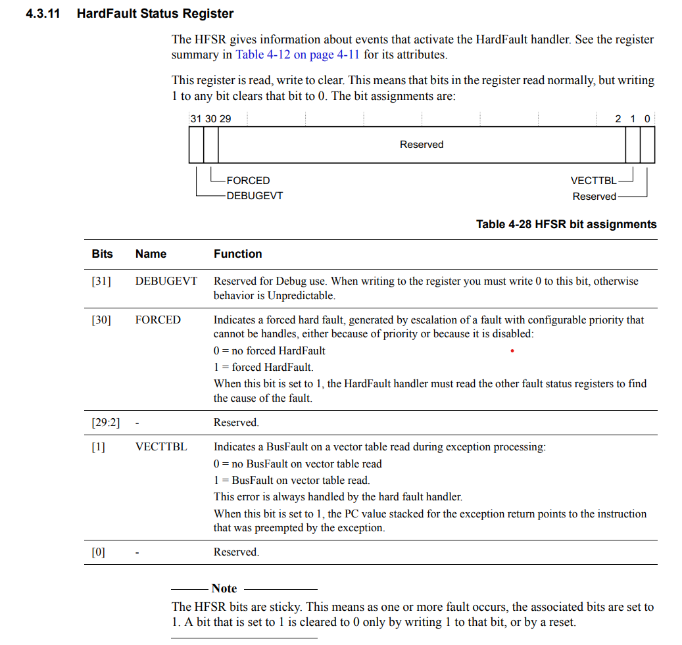

**Mem manage fault exception:**

• This is a configurable fault exception. Disabled by default

• You can enable this exception by configuring the processor register “System Handler Control

and State Register(SHCSR)”

•When mem mange fault happens mem manage fault exception handler will be executed by the

processor

• Priority of this fault exception is configurable

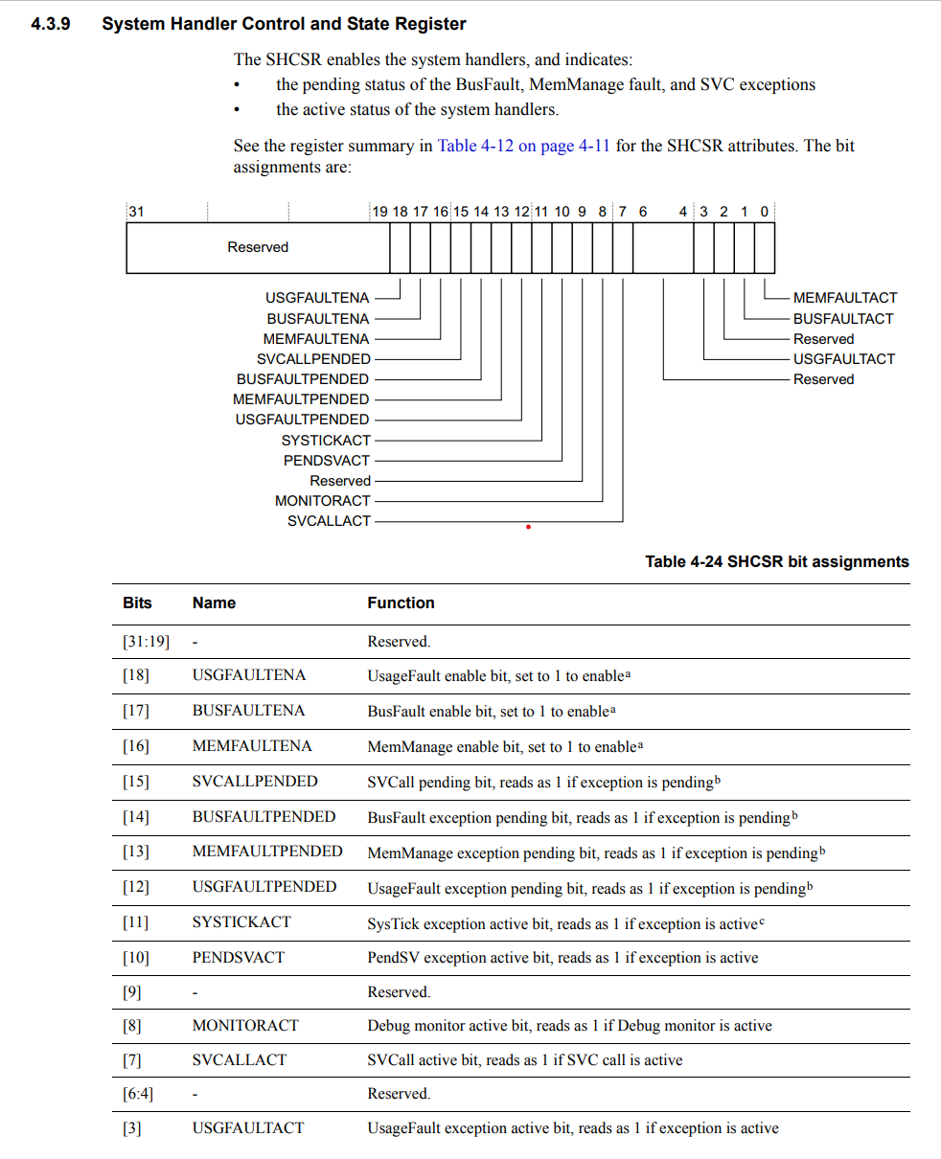

**Causes**

1. As its name indicates this fault exception triggers when memory access violation is detected (access permission by the processor or MPU)

2. Unprivileged thread mode code (such as user application or RTOS task ) tries to access a memory region which is marked as “privileged access only “ by the MPU

3. Writing to memory regions which are marked as read-only by the MPU4.

4. This fault can also be triggered when trying to execute program code from “peripheral “ memory regions. Peripheral memory regions are marked as XN(eXecute Never) regions by the processor design to avoid code injection attacks through peripherals.

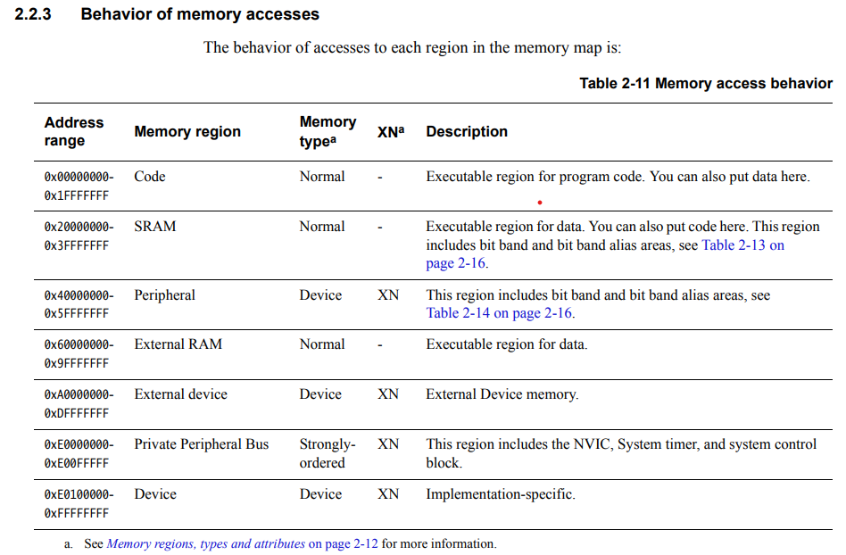

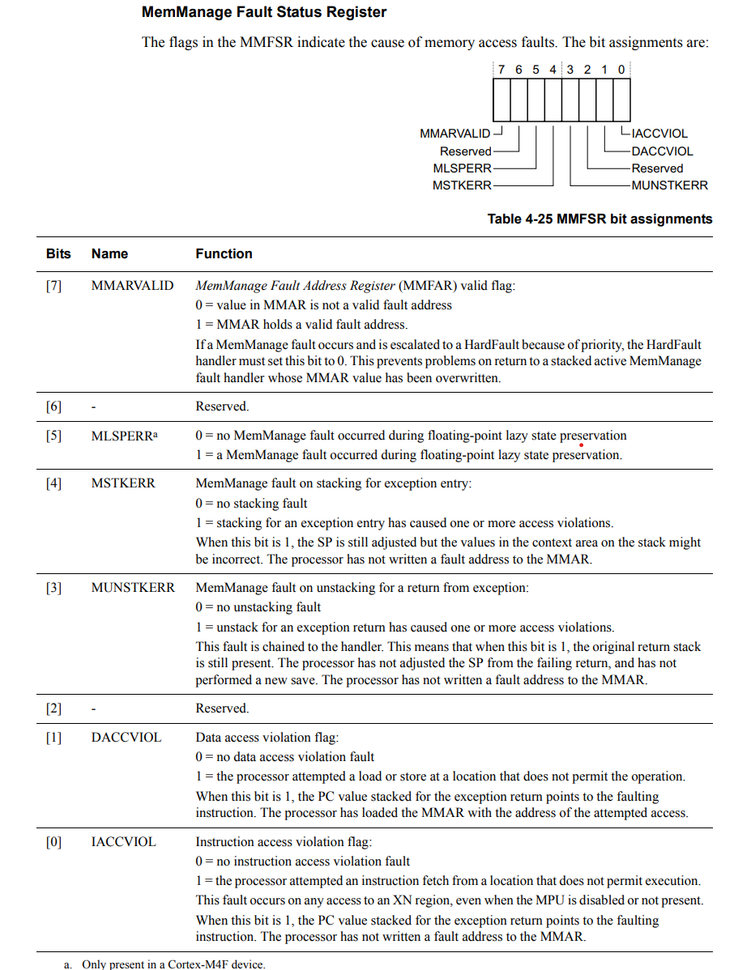

**Bus-fault exception :**

**Causes**

✔ Due to error response returned by the processor bus interfaces during access to memory

devices ▪ During instruction fetch ▪ During data read or write to memory devices

✔ If bus error happens during vector fetch, it will be escalated to a hard fault even if bus fault

exception is enabled

✔ Memory device sends error response when the processor bus interface tries to access invalid

or restricted memory locations which could generate a bus fault

✔ When the device is not ready to accept memory transfer

✔ You may encounter such issues when you play with external memories such as SDRAM

connected via DRAM controllers

✔ Unprivileged access to the private peripheral bus

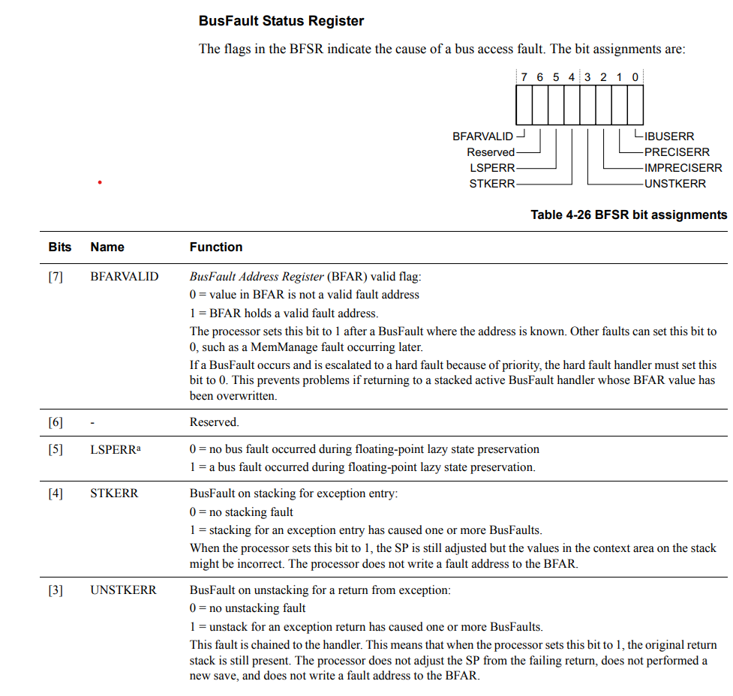

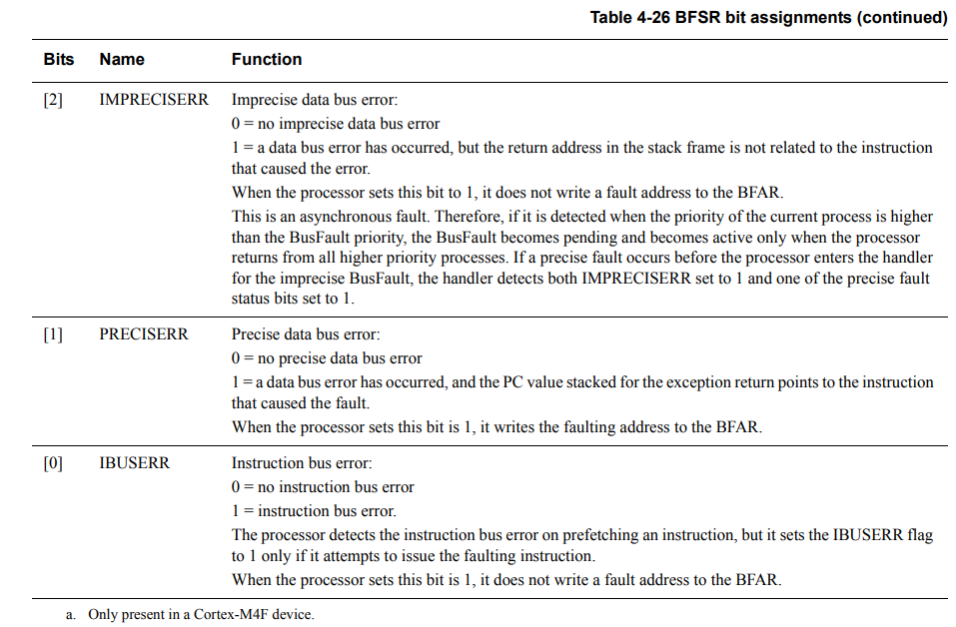

**Usage fault exception :**

**Causes**

✔ Execution of undefined instruction (Cortex M4 supports only thumb ISA, so executing any

instruction outside this ISA(like ARM ISA) would result in a fault )

✔ Executing floating point instruction keeping floating point unit disabled

✔ Trying to switch to ARM state to execute ARM ISA instructions. The T bit of the processor

decides ARM state or THUMB state. For cortex M it should be maintained at 1. Making T bit 0

(may happen during function call using function pointers whose 0th bit is not maintained as 1

) would result in a fault

✔ Trying to return to thread mode when an exception/interrupt is still active

✔ Unaligned memory access with multiple load or multiple store instructions

✔ Attempt to divide by zero (if enabled, by default divide by zero results in zero)

✔ For all unaligned data access from memory ( only if enabled, otherwise cortex m supports

unaligned data access )

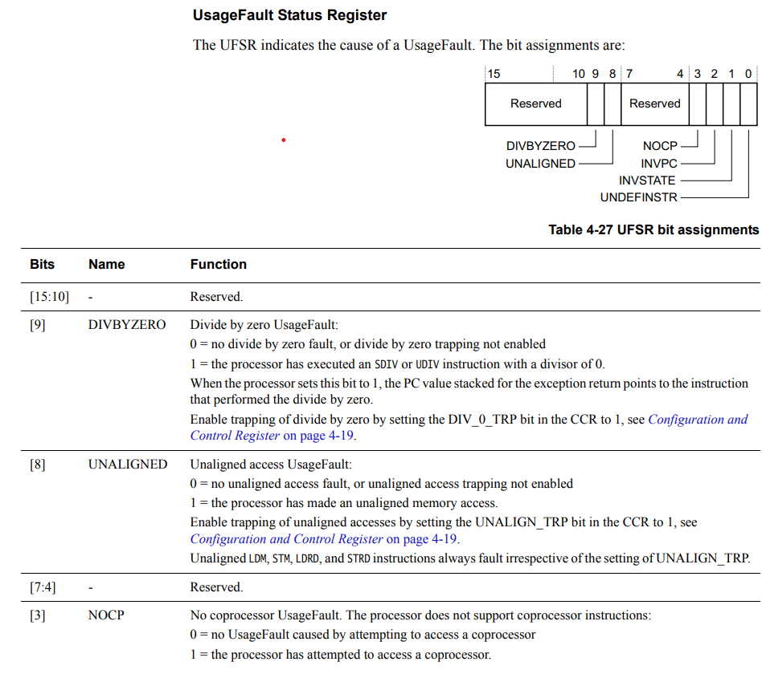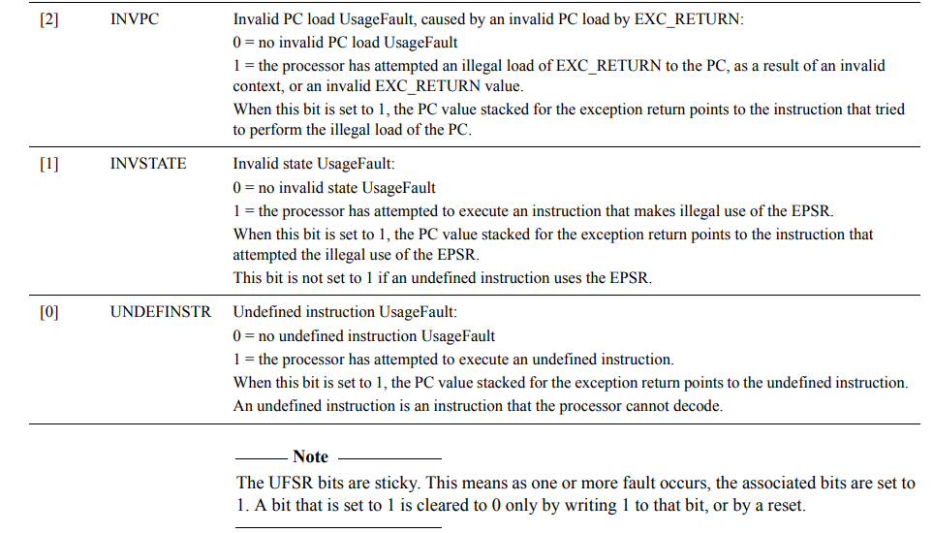

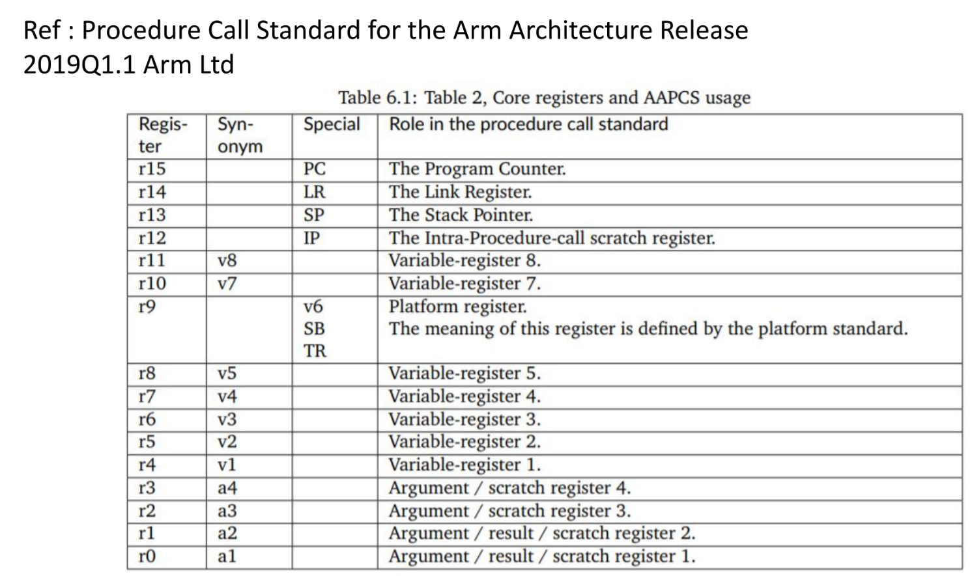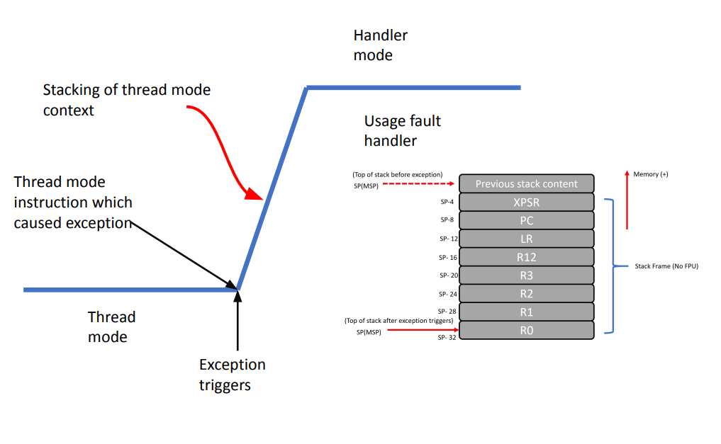**Analyzing stack frame:**

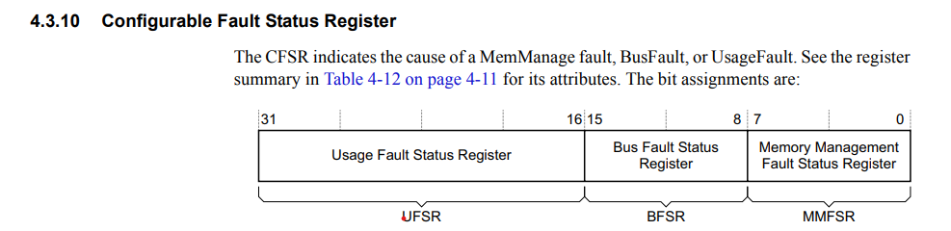

Exceptions for system-level services

•ARM cortex Mx processor supports 2 important system-level service exceptions. SVC(SuperVisor Call ) and PendSV(Pendable SerVice)

• Supervisory calls are typically used to request privileged operations or access to system resources from an operating system.

• SVC exception is mainly used in an OS environment. For example, A less privileged user task can trigger SVC exception to get system-level services(like accessing device drivers, peripherals) from the kernel of the OS

• PendSV is mainly used in an OS environment to carry out context switching between 2 or more tasks when no other exceptions are active in the system.

**SVC (Supervisor Call ) instruction:**

• SVC is a thumb ISA instruction which causes SVC exception

• In an RTOS scenario, user tasks can execute SVC instruction with an associated argument to make supervisory calls to seek privileged resources from the kernel code

• Unprivileged user tasks use the SVC instruction to change the processor mode to privileged mode to access privileged resources like peripherals

• SVC instruction is always used along with a number, which can be used to identify the request type by the kernel code

• The svc handler executes right after the SVC instruction(no delay. Unless a higher priority exception arrives at the same time )

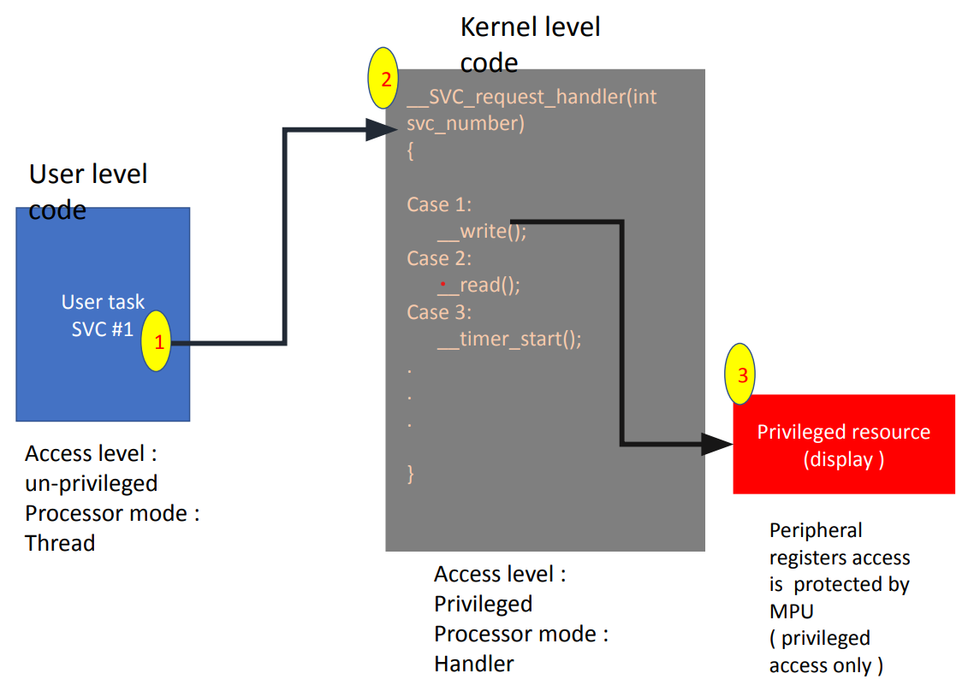

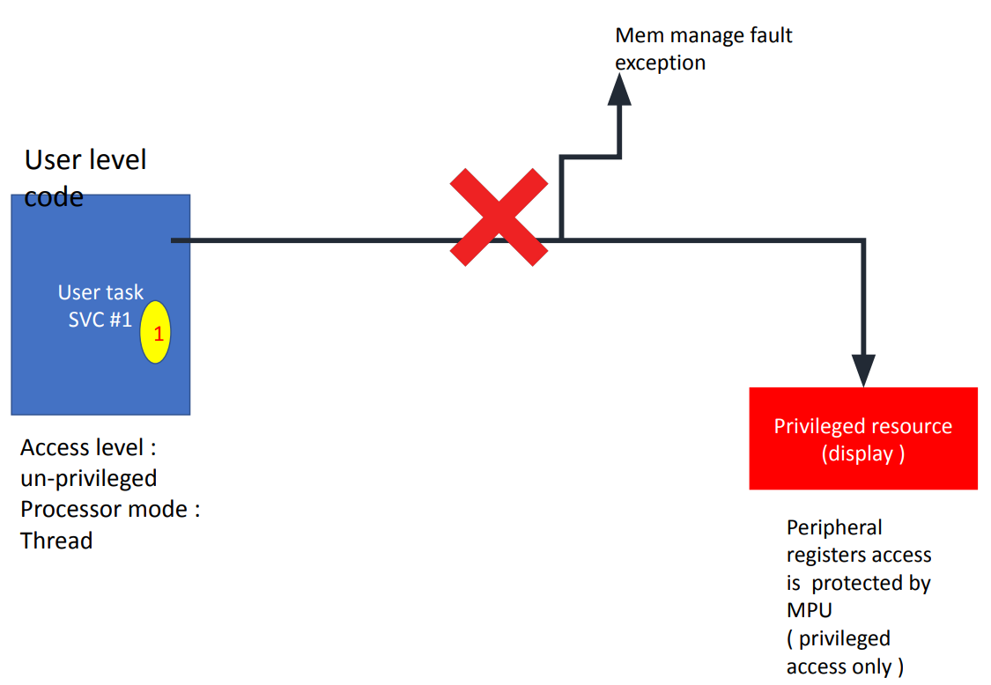

**Methods to trigger SVC exception:**

There are two ways –

1) Direct execution of SVC instruction with an immediate value Example : ‘SVC #0x04’ in assembly (Using SVC instruction is very efficient in terms of latency )

2) Setting the exception pending bit in “System Handler Control and State Register” (uncommon method )

**How to extract the SVC number:**

• The SVC instruction has a number embedded within it, often referred to as the SVC number

•In the SVC handler, you should fetch the opcode of the SVC instruction and then extract the SVC number

• To fetch the opcode of SVC instruction from program memory, we should have the value of PC(return address) where the user code had interrupted while triggering the SVC exception

• The value of the PC(Return address) where the user code had interrupted is stored in the stack as a part of exception entry sequence by the processor.

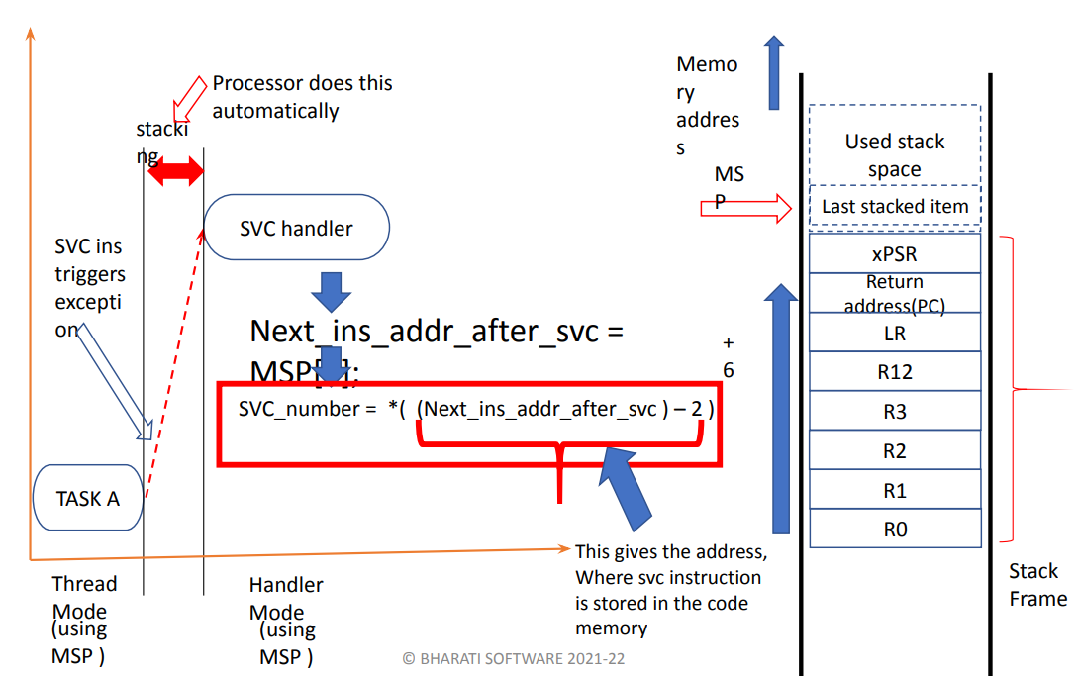

**PendSV Exception:**

•It is an exception type 14 and has a programmable priority level.

• This exception is triggered by setting its pending status by writing to the “Interrupt Control and State Register” of processor

• Triggering a pendSV system exception is a way of invoking the pre-emptive kernel to carry out the context switch in an OS environment

•In an OS environment, PendSV handler is set to the lowest priority level, and the PendSV handler carries out the context switch operation

**Typical use of PendSV:**

✔ Typically this exception is triggered inside a higher priority exception handler, and it gets executed when the higher priority handler finishes.

✔ Using this characteristic, we can schedule the PendSV exception handler to be executed after all the other interrupt processing tasks are done.

✔ This is very useful for a context switching operation, which is a crucial operation in various OS design.

✔Using PendSV in context switching will be more efficient in an interrupt noisy environment.

✔In an interrupt noisy environment, and we need to delay the context switching until all IRQ are executed.

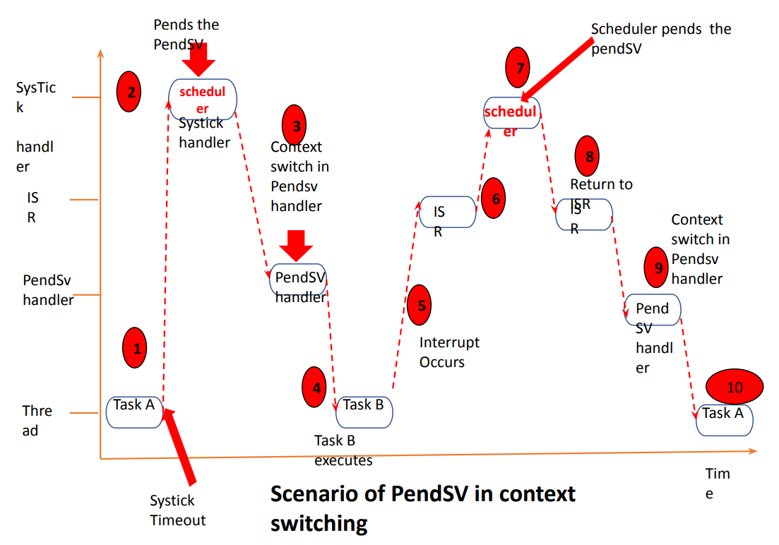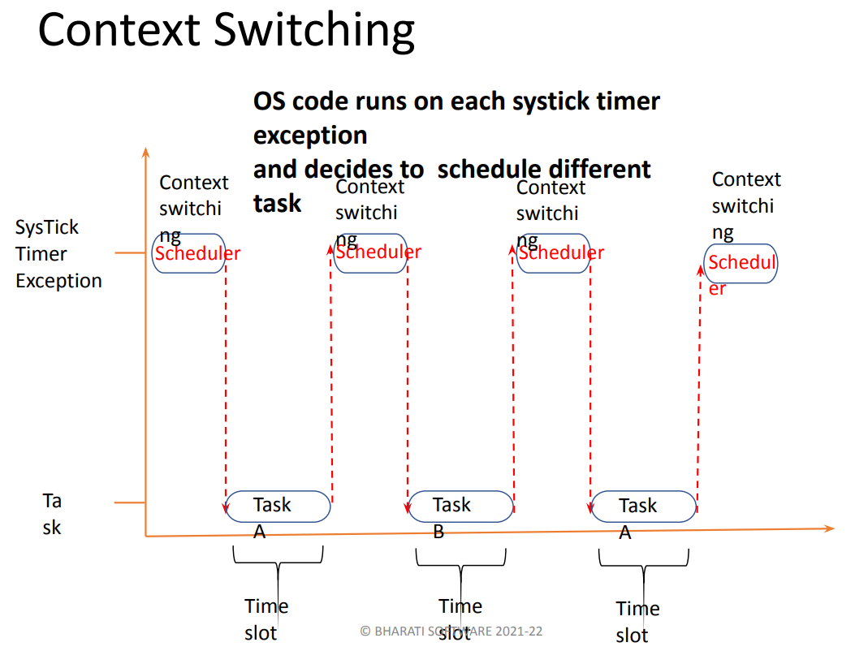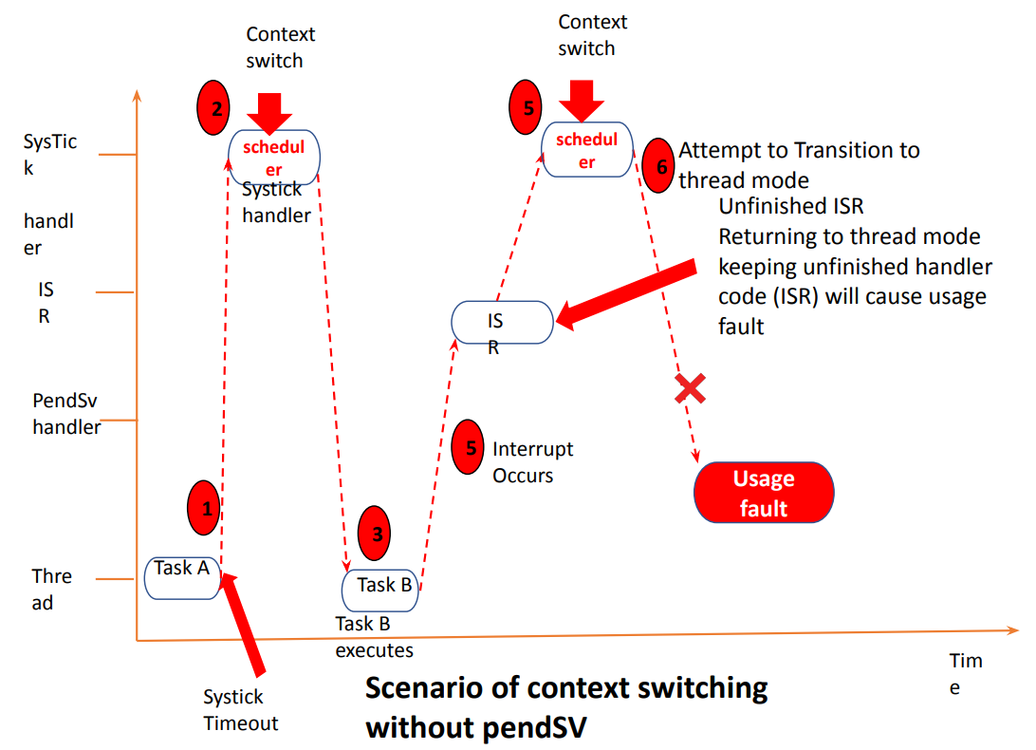

**PendSV other use cases:**

•Offloading Interrupt processing

•If a higher priority handler is doing time-consuming work, then the other lower priority interrupts will suffer, and systems responsiveness may reduce. This can be solved using a combination of ISR and pendSV handler

**Offloading Interrupt Processing Using Pendsv**

Interrupts may be serviced in 2 halves.

1) The first half is the time critical part that needs to be executed as a part of ISR.

2) The second half is called bottom half, is basically delayed execution where rest of the time-consuming work will be done .

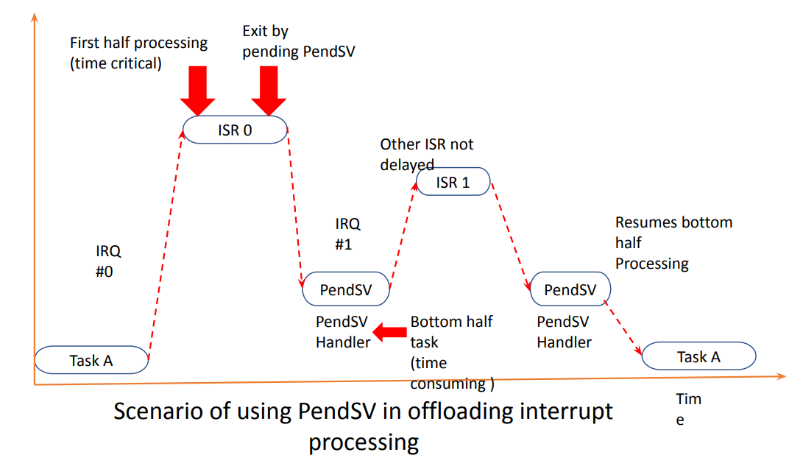So, PendSV can be used in these cases, to handle the second half execution by triggering it in the first half.

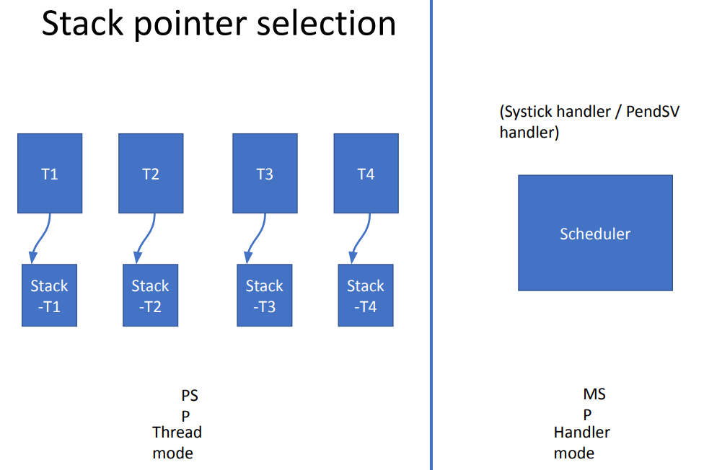Implementation of Scheduler

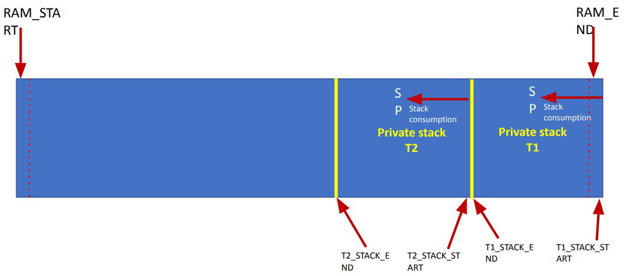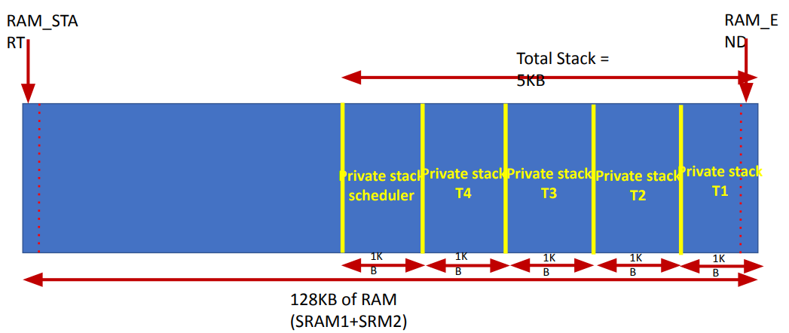**Stack configuration :**

**Scheduling policy selection :**

• We will be using round robin pre-emptive scheduling

• No task priority

• We will use SysTick timer to generate exception for every 1ms to run the scheduler code

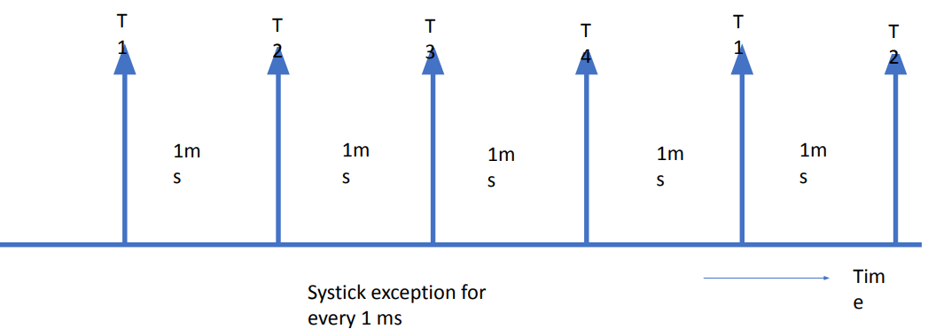

**State of a task :**

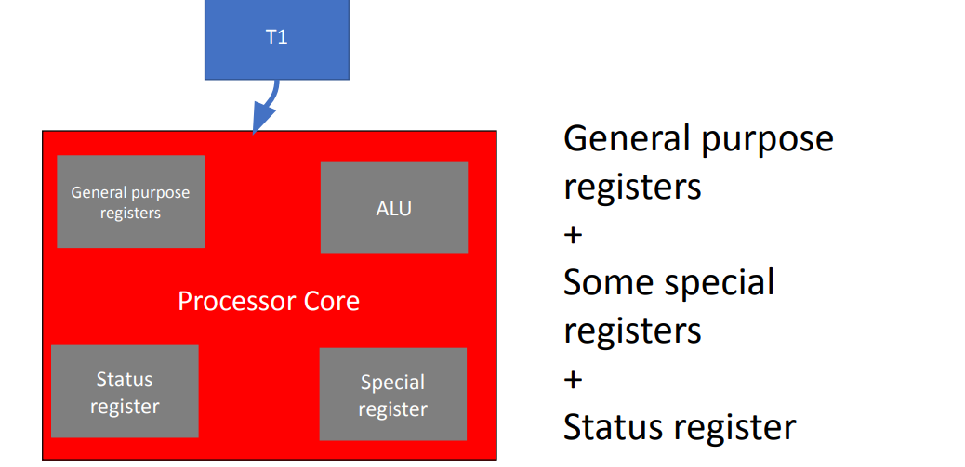

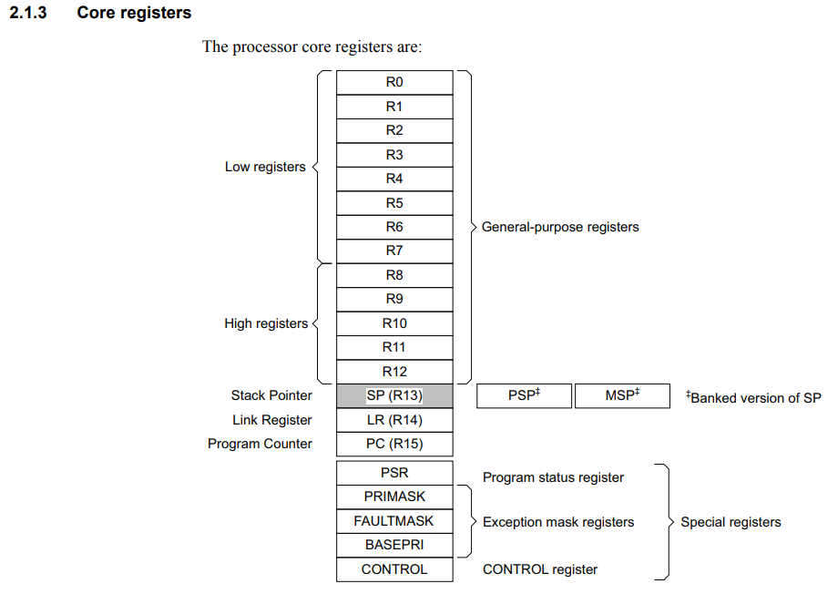

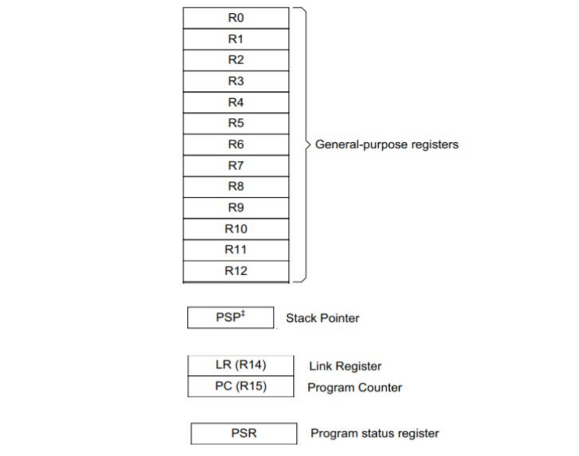**Summary: State of a task -**

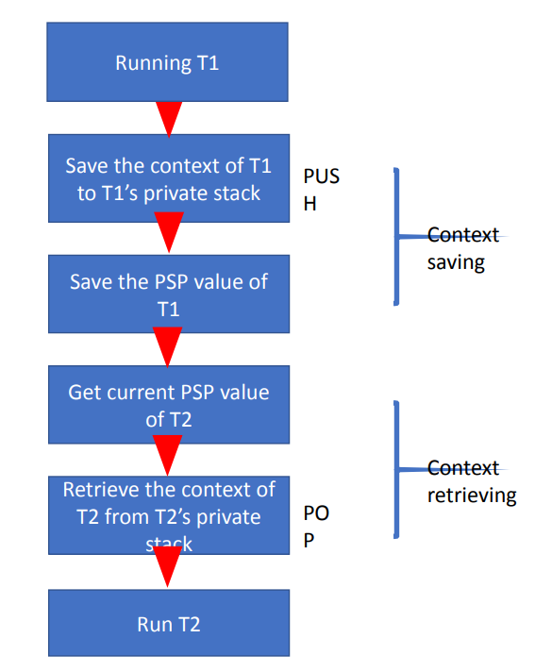**Case of T1 switching out, T2 switching in :**

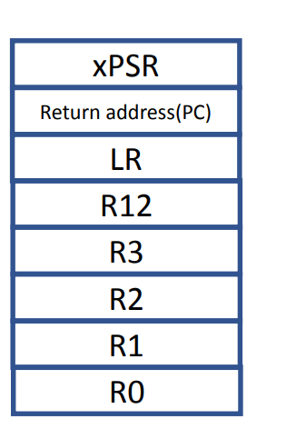

Stack Frame

**SysTick count value calculation :**

• Processor Clock = 16MHz

• SysTick timer count clock = 16MHz

• 1ms is 1KHz in frequency domain

• So, to bring down SysTick timer count clock from 16MHz to 1KHz use a divisor (reload value )

• Reload value = 16000

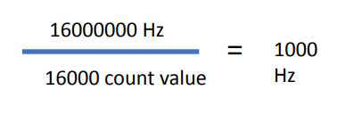

(Desired exception frequency)

**SysTick timer count clock = 16MHz For 1 count it takes 0.0625 micro seconds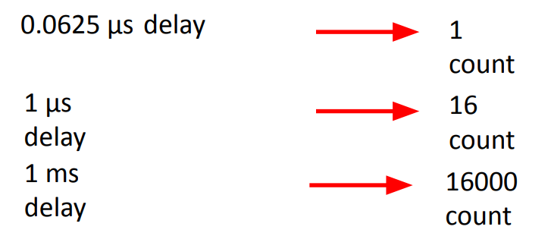 -**

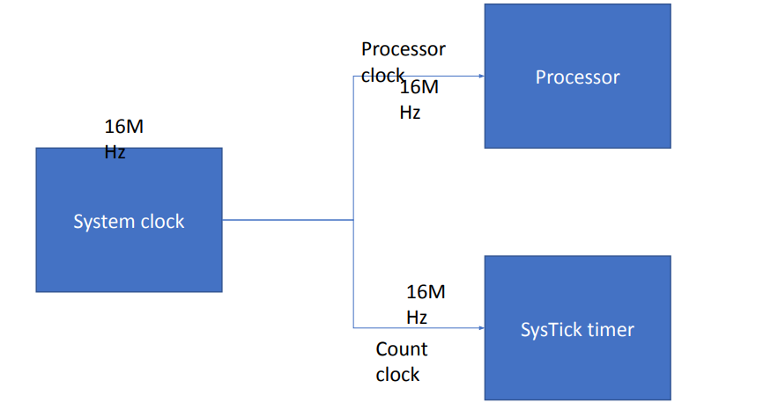

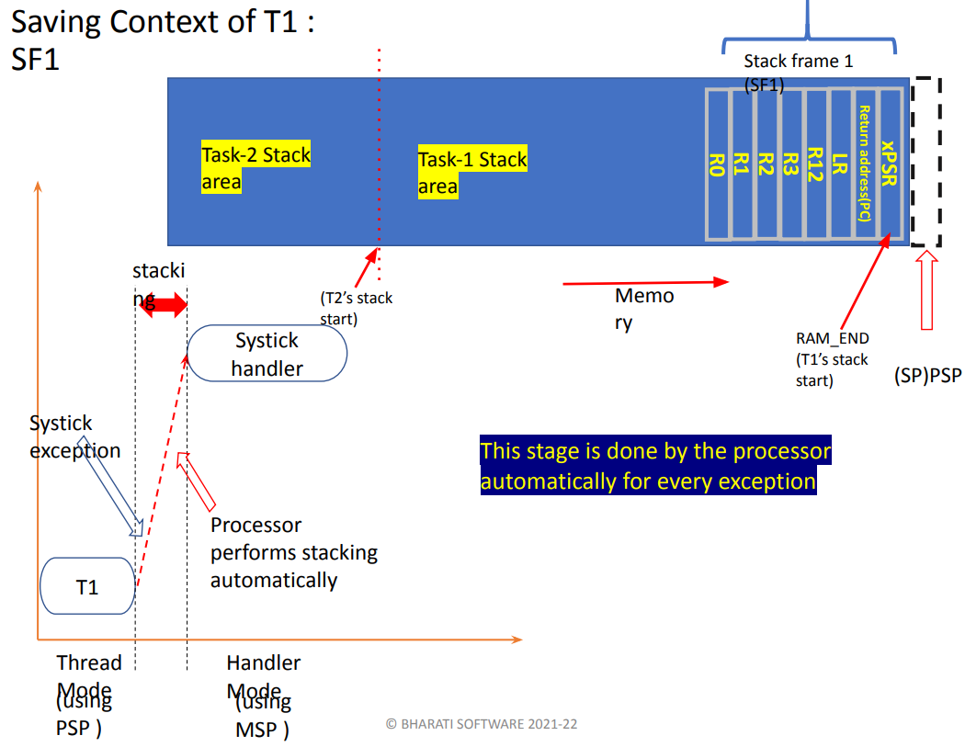

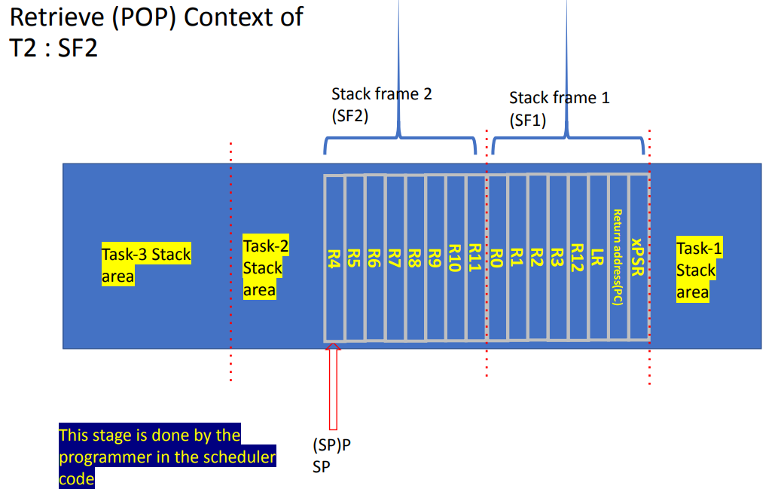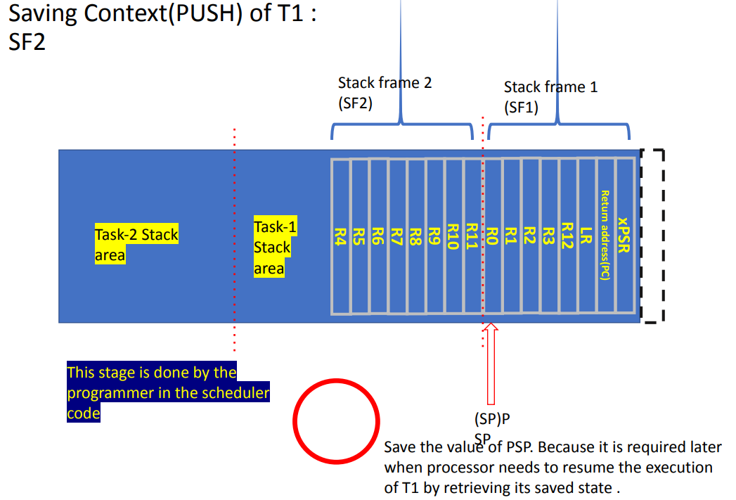

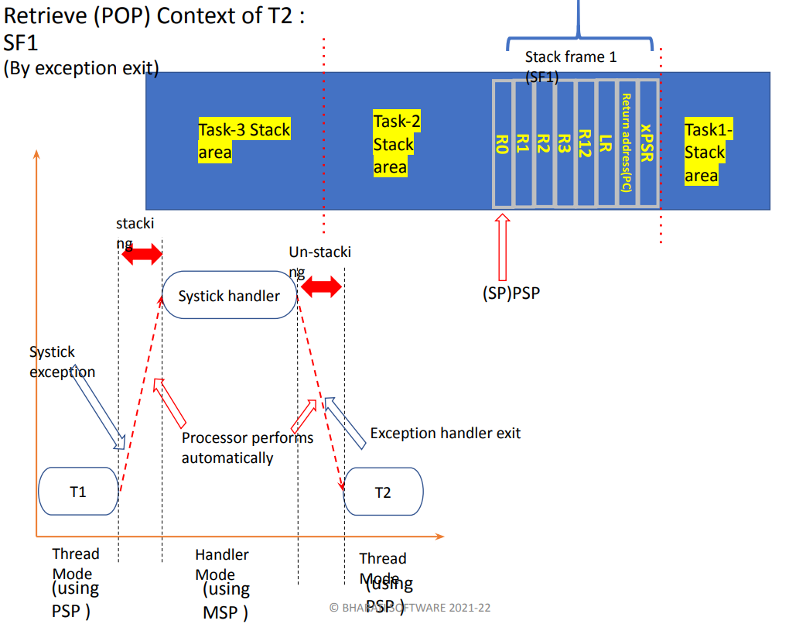

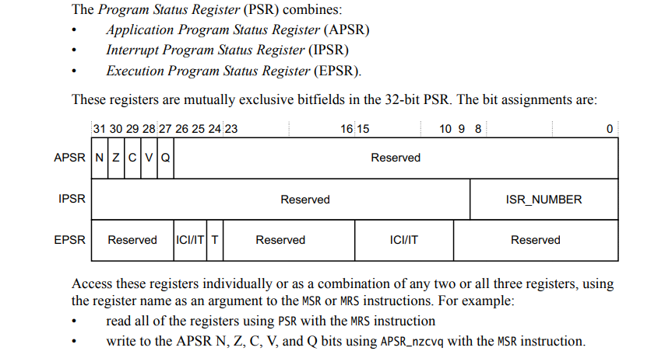**Dummy initial context of a Task :**

